Part [0] Vulnerabilities Understanding

Vulnerability #1

GNU Screen 4.5.0 - Local Privilege Escalation

Vulnerability overview:

This vulnerability, indexed as EDB-ID 41154, targets GNU Screen version 4.5.0. It permits local users to gain root privileges by exploiting improper logfile permission checks within the Screen program.

Details about vulnerability:

Its vulnerability that allows local users to modify any files and consequently gain root privileges by take advantage from improper checking of logfile permissions by this the file would be created with the same permission as the root. It used to create any files with root permissions containing any content. If the Screen program is owned by root, the files created will be owned by root as well.

Explanation:

Vulnerability on Linux systems running Screen version 4.5.0 with setuid root. The vulnerability involves configuring the vulnerable Screen version. Use of the **-L** flag in Screen creates a logfile (ld.so.preload) without proper permission checks, which will give root-level access.

Recommendations for mitigations

Update the screen to the latest version that adding permissions check for the logfile name: The code change involves checking if the screen logfile can be opened for writing and taking appropriate action if there are any issues, preventing the vulnerability in the script. This change would avoid the security issue by ensuring that the logfile is writable.

Vulnerability #2

Maltrail v0.53 – Unauthenticated

Unauthenticated os command Remote Code Execution

Vulnerability overview:

The vulnerability (EDB-ID: 51676) in Maltrail version 0.52, enabling unauthenticated users to inject OS commands through the username input. The vulnerability uses the subprocess.check_output() function to execute a shell command that logs the username.

Details about vulnerability:

The exploit creates a reverse shell payload encoded in Base64 to bypass potential protections like WAF, IPS or IDS and delivers it to the target URL using a curl command. Then it will executed on the target system and making a reverse shell connection in the attacker's IP and its listening port.

Explanation:

The vulnerability allow unauthorized command execution due to not sanitizing input validation. This vulnerability enables attackers to execute arbitrary commands on the target system through the username input, leading to a reverse shell connection.

Recommendations for mitigations

The vulnerability has been solved in the new versions by setting **shell=False**, preventing shell injection attempts and enhancing the security of Maltrail systems.

This mitigation technique restricts command execution within a shell environment, to prevent the vulnerability's exploitability.

Vulnerability #3

WordPress Plugin Secure Copy Content Protection and Content Locking 2.8.1 – SQL-Injection (Unauthenticated)

Vulnerability overview:

The vulnerability (CVE: 2021-24931) it’s in the WordPress plugin Secure Copy Content Protection and Content Locking version 2.8.1 that enable SQL Injection through the 'sccp_id' parameter in the ays_sccp_results_export_file AJAX action.

This vulnerability allows both authenticated and unauthenticated users to manipulate SQL queries.

Details about vulnerability:

The plugin doesn't sanitize or validate the 'sccp_id' parameter that came from both authenticated and unauthenticated users, making it target to SQL injection attacks.

Explanation:

Exploiting this vulnerability involves make a specific SQL injection payload through the 'sccp_id' parameter, allowing attackers to alter SQL queries used in the AJAX action. This alteration will cause unauthorized data access.

Recommendations for mitigations

The mitigations aim to prevent unauthorized SQL injection by sanitizing user inputs and using secure SQL queries, also it attempts to convert the 'sccp_id' values to integers using intval(). And this mitigation is in the new version of it.

**Part [1] System Design, Architecture, & Administration**

**Environment Architecture**

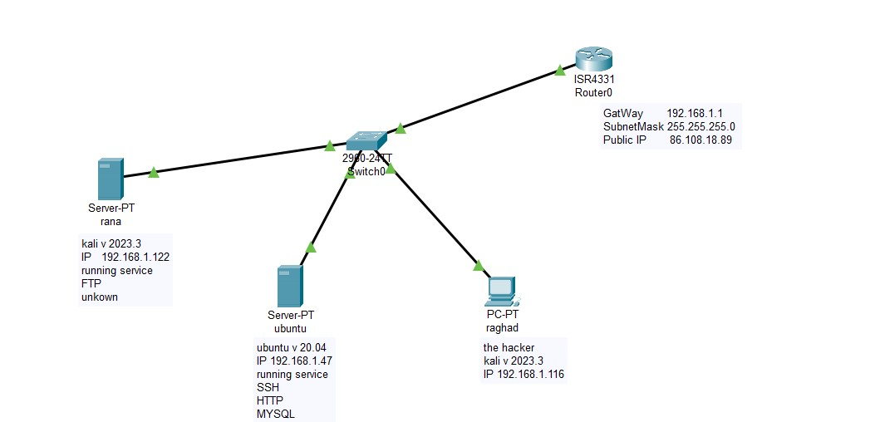

**IP Addresses Plan**

|  |  |  |
| --- | --- | --- |
| Public IP | [86.108.18.89](https://www.whatismyip.com/ip/86.108.18.89/) | |
| Gateway | 192.168.1.1 | |
| Subnet mask | 255.255.255.0 | |
| Device Name | MAC Address | IP Address |
| Ubuntu | 00:0c:29:08:36:22 | 192.168.1.47 |
| rana | 00:0c:29:6a:a2:d2 | 192.168.1.122 |
| raghad | 00:0c:29:7a:7a:c0 | 192.168.1.116 |

**List of all the running services in your environment, with a brief explanation for each service, its purpose, and its installation steps**

**VM1 (List of all the running services)**

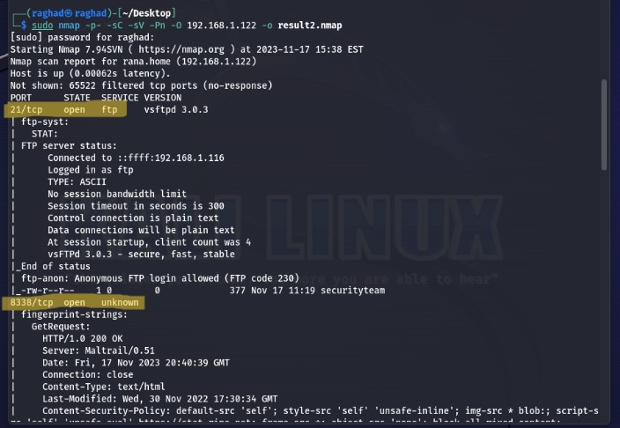

1. **FTP Server (File Transfer Protocol):( brief explanation for each service, its purpose)**

**file transfers between a client and a server on a network. It allows users to upload, download, rename, delete, and manipulate files on a remote server.**

**In Linux, when installing FTP service, the most common FTP server software is VSFTPD (Very Secure FTP Daemon).**

**So, the installation command for the FTP service involves installing the vsftpd package.**

**Installation Steps (for vsftpd - Very Secure FTP Daemon):( its installation steps)**

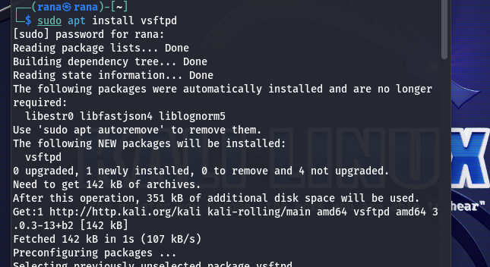

**Enable vsftp:**

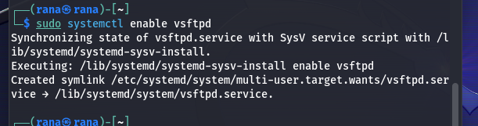

**Start vsftp:**



**Configuration:** After installation, edit the configuration file (**/etc/vsftpd.conf**) :

* **anonymous_enable=YES:**

Allows anonymous FTP access. Users can log in without providing a username or password.

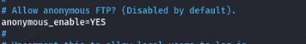

Allow it to create new directory

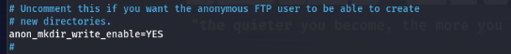

Allow it to upload files

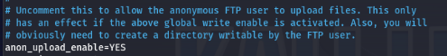

* **local_enable=YES:**

Allows local users (system users) to log in to the FTP server using their credentials.



* **pasv_enable=YES:**

Provides the client with an IP address and a range of ports (passive port range) when the client connect for data transfer.becouse if we use active mode this can cause issues if the client firewall is running.

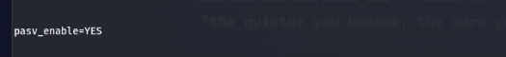

Set the range of ports for data transfer.



Allow the range of passive ports from 10400 to 10410

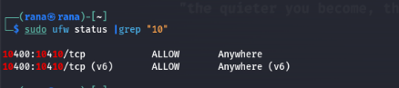

Allow ftp connection in port 21

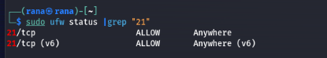

**2. Maltrail v0.51 :(brief explanation for each service, its purpose)**

**It’s an IDS capturing and logging network traffic that might have malicious activity. It track and detect potential threats in network traffic it also use blacklists of known malicious IPs, domains, and URLs And It generates alerts and logs information about the traffic patterns, source IPs, destination IPs, and other relevant details.**

**Installation Steps :( its installation steps)**

**Download it from githup**

[**https://github.com/stamparm/maltrail/releases/tag/0.52**](https://github.com/stamparm/maltrail/releases/tag/0.52)

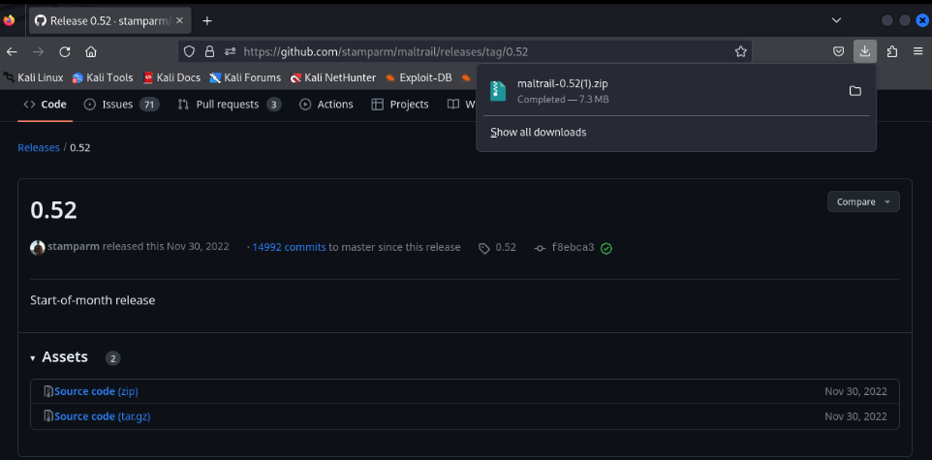

**Then unzip it**

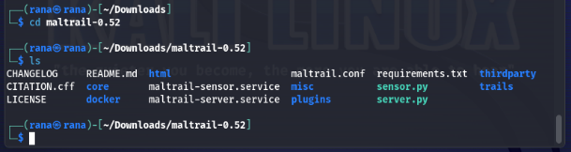

**Add new rule to the ufw to allow incoming connection in port 8338**

**Because its the default running port for it.**

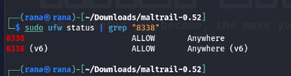

**Run it**

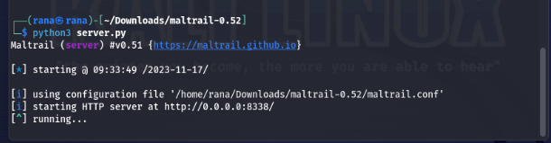

**VM2**:( **List of all the running services)**

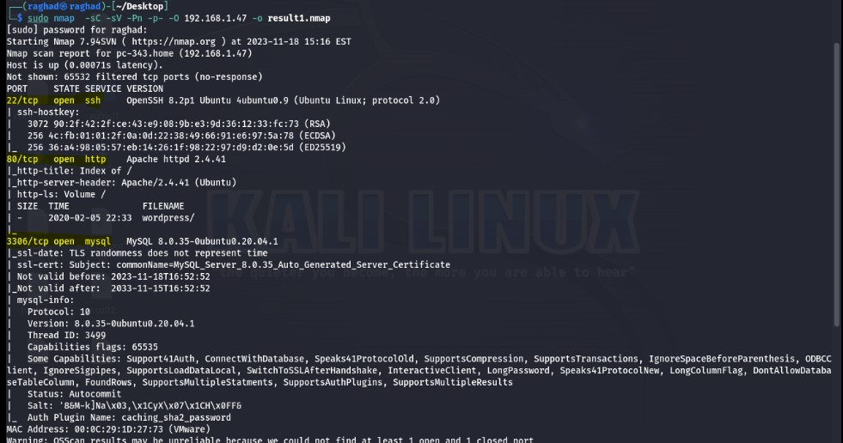

**1. MYSQL: (Brief explanation for each service, its purpose)**

**MySQL is an open-source relational database management system (RDBMS) it use to store, organize, and retrieve data as requested by other software applications.it allows us to store various types of data. And uses tables to organize data into rows and columns.**

**Installation Steps for (MYSQL):**

**Install mysql database**

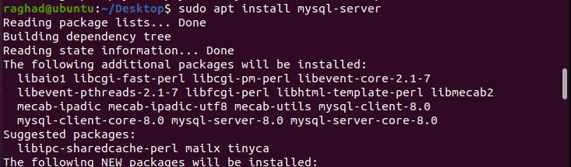

**Configure its security**

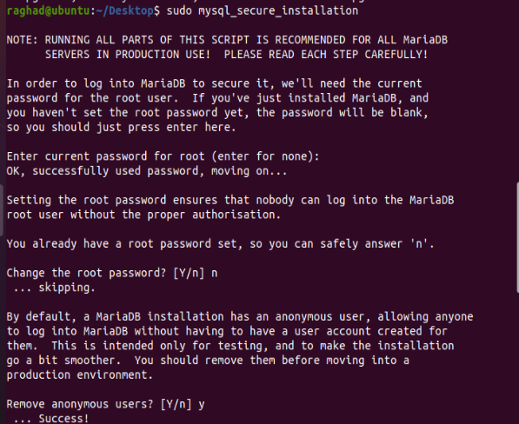

**Start it and enable it**

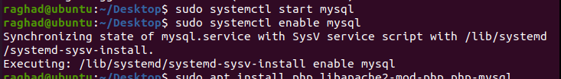

**Apache :( brief explanation for each service, its purpose)**

**It is a HTTP Server ,it is open-source web It's known for its reliability, and flexibility. Apache is primarily used to serve web content over the internet, making it accessible to users via their web browsers.**

**Installation Steps for (apache)**

**Install it**

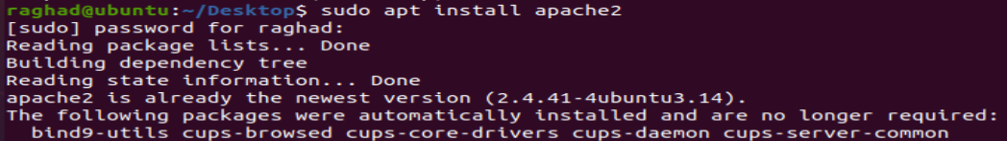

**Start and enable it**





**SSH: (brief explanation for each service, its purpose)**

**SSH stands for Secure Shell, it is a network protocol that allows secure communication between two computers by establishing a secure, encrypted connection over an insecure network. Its primary purpose is to provide a secure way to access and manage your device remotely.**

**Installation Steps for (SSH)**

**Install openssh :OpenSSH is one of the implementations of the SSH protocol**

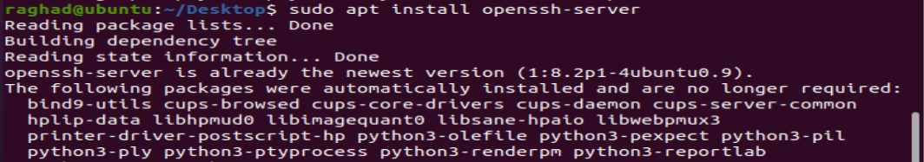

**Start it and enable it**



**Screenshots showing the services are running as expected in your environment and are normally accessible by users. (Show how normal users use the services)**

**VM1:**

**FTP: running as expected**

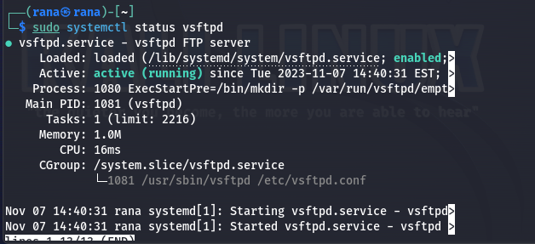

**Access as anonymous user and see the files and can download the files in it: Show how normal users use the services**

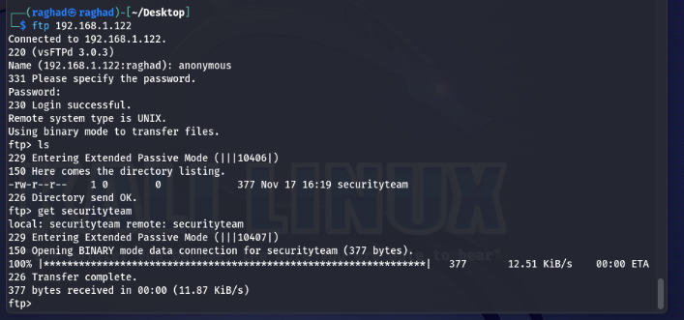

**Access as a user called rana: Show how normal users use the services and normally accessible by users**

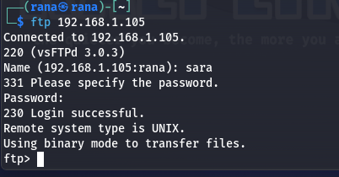

**Maltrail: running as expected**



**Access as admin user: normally accessible by users**

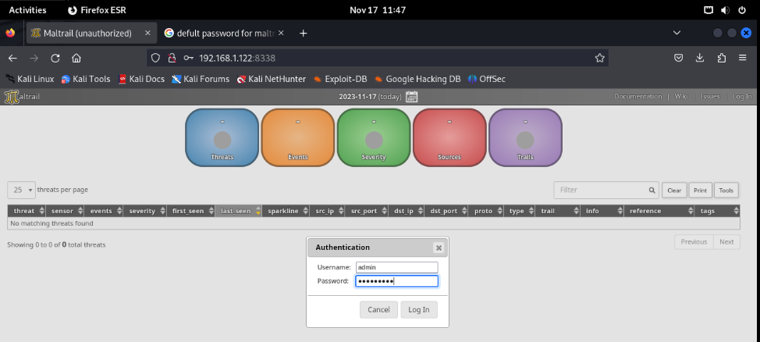

**After access it the user can check if there is any malicious activity in the network.**

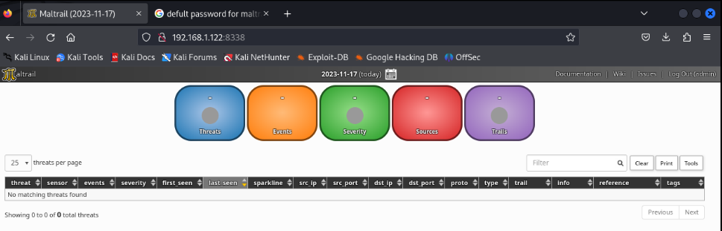

**It will appear here:**

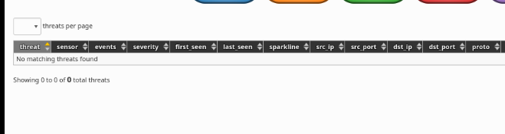

**It can add note about the IPs different labels to the same IP address or network segment. For example, tagging an IP as "suspicious" or "malicious".**

**Show how normal users use the services**

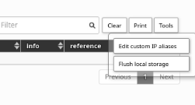

**Like this:**

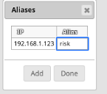

**VM2**

**MYSQL: running as expected**

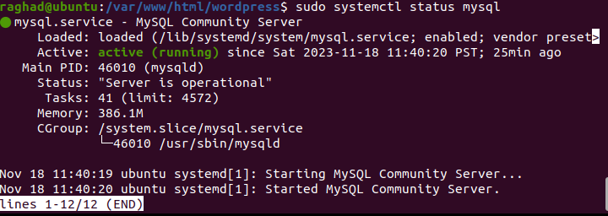

**Access it as a root user Show how normal users use the services and normally accessible by users**

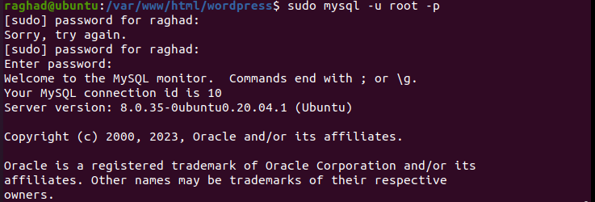

**Access it as a user called raghad5 and use it to see the databases and access its tables Show how normal users use the services**

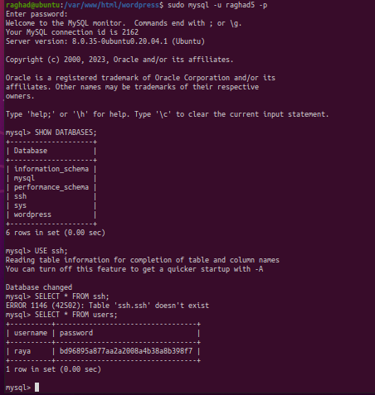

**Apache: running as expected**

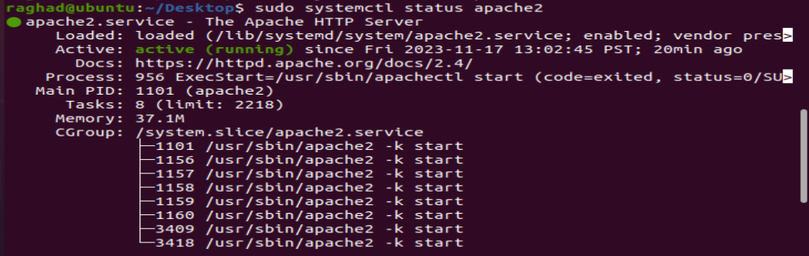

**You can make a page or website in the default path in /var/www/html directory and access it using the ip of the machine**

**Show how normal users use the services**

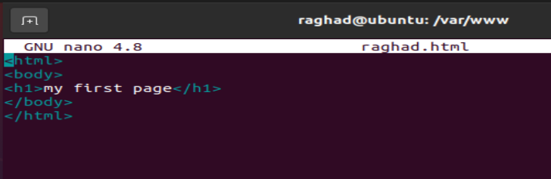

**Access the page and the website normally accessible by users**

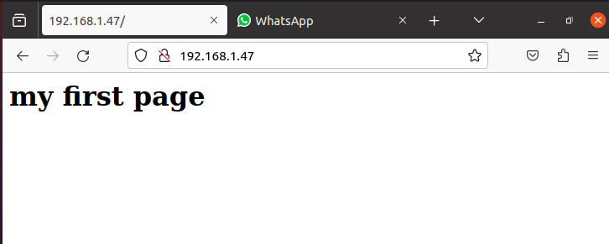

**The website:**

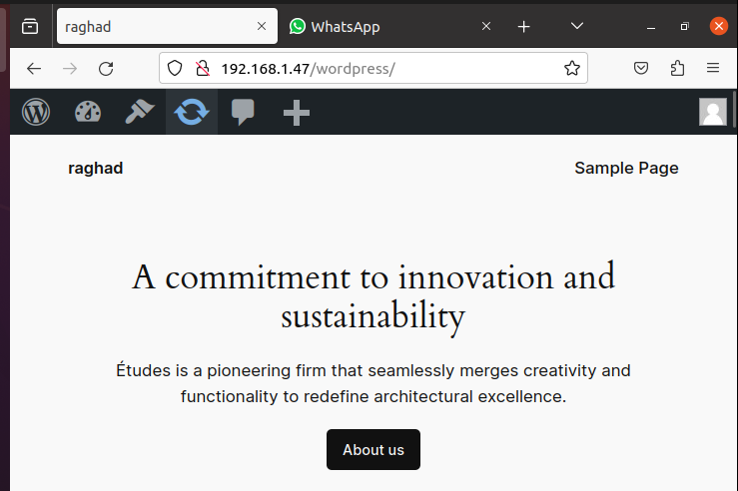

**SSH: running as expected**

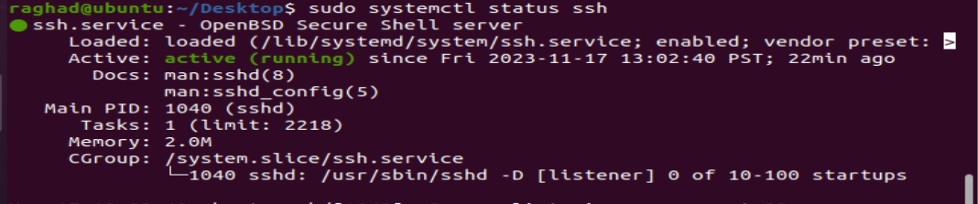

**Show how normal users use the services and normally accessible by users by accessing as a user called raghad remotely.**

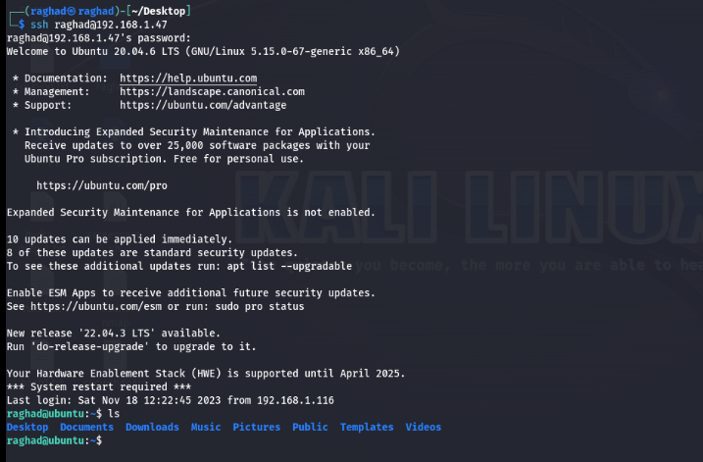

**Part [2] Offensive Cybersecurity**

**Executive Summery**

**The Red Team test the security of the two servers machine "ubuntu" and "rana", and identified vulnerabilities in them. Here are the key findings and recommended mitigations:**

**The “ubuntu server”**

**WordPress Server Vulnerabilities:**

**SQL Injection in WordPress Plugin: Identified in the Secure Copy Content Protection plugin, allowing unauthorized SQL injection.**

**Mitigation: Urgent update of the plugin to the latest version that will sanitize the input and strong password enforcement.**

**Weak Passwords:**

**Easily guessable passwords like “password123” caused unauthorized access to admin privileges.**

**Mitigation: Enforce strong password policies, ensuring complexity and regular password changes.**

**MySQL Server Vulnerabilities:**

**Weak Passwords and Brute-Force Attacks: Easily guessable password "!!password!!" Caused unauthorized database access.**

**Mitigation: Immediate password change, make strong password policies, and rate limiting for login attempts.**

**Using MD5 Hash for Passwords:**

**Vulnerable hashing mechanism that can be easily cracked.**

**Mitigation: Upgrade to stronger hashing like sha512 for password stored in the databases.**

**The “rana server”**

**FTP Server Vulnerabilities:**

**Unauthorized Access and Data Exposure: Anonymous login allows access to sensitive security team files.**

**Mitigation: Disable anonymous login, enforce user authentication, and enable the logging for access monitoring.**

**Maltrail Server Vulnerabilities:**

**Command Injection via Login Page: Lack of input validation in the login page allows attackers to inject OS commands.**

**Mitigation: Update Maltrail to the latest version or configure the application to prevent shell creation.**

**Screen Tool Vulnerabilities:**

**Privilege Escalation: allows local users to modify any files and gain root privileges by take advantage from improper checking of logfile permissions.**

**Mitigation: Update the screen to the latest version that adding permissions check for the logfile name**

**Immediate Actions:**

**Update WordPress plugins and MySQL configurations to avoid the vulnerabilities.**

**Security Measures:**

**Enforce strong password policies to all servers and disable anonymous access to FTP.**

**Continuous Monitoring:**

**Make logging and monitoring to detect any malicious activities.**

**Regular Updates:**

**Regular system updates to mitigate potential vulnerabilities.**

**Findings and Attack Narrative**

**First we started with the "Ubuntu" server and scan it using nmap.**

**-sV: to determine service/version information in the open ports.**

**-sC: Show the running default scripts.**

**-p-: Scan all 65535 ports.**

**-Pn: Treat host as online.**

**-o: Save the output of the nmap in the file named result1.nmap.**

**-O: to know the operating system.**

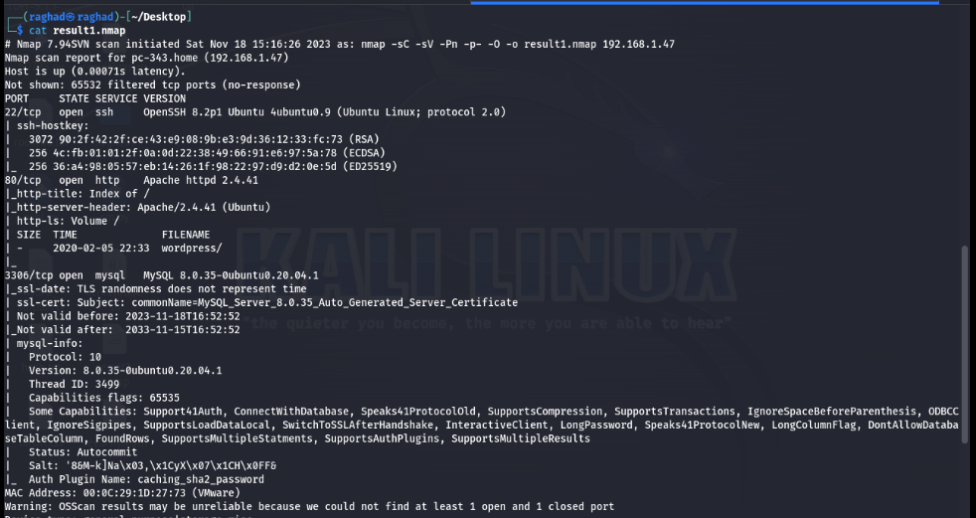

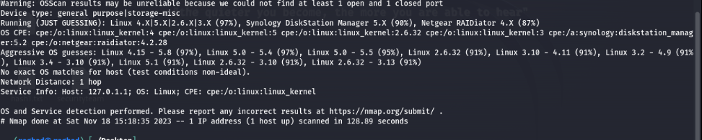

**The result show that there is 4 open ports with running services,The 22/tcp port running ssh connection ,the 80/tcp port running the http which mean that it could be a website there and the 3306 port which is the default port to run mysql.**

**In ssh service show that we can connect remotely using ssh to the server, the http show that there is a directory named wordpress so we tried to access it, also it show the apache version 2.4.41 and it show that the home page title is index.**

**And 3306 port running a database that is mysql with version 8.0.35.Also it show that the operating system could be from Linux distribution.**

**Second we started with port 80 by visit the worpress directory**

**And we found this website in this page we didn’t found anything unique**

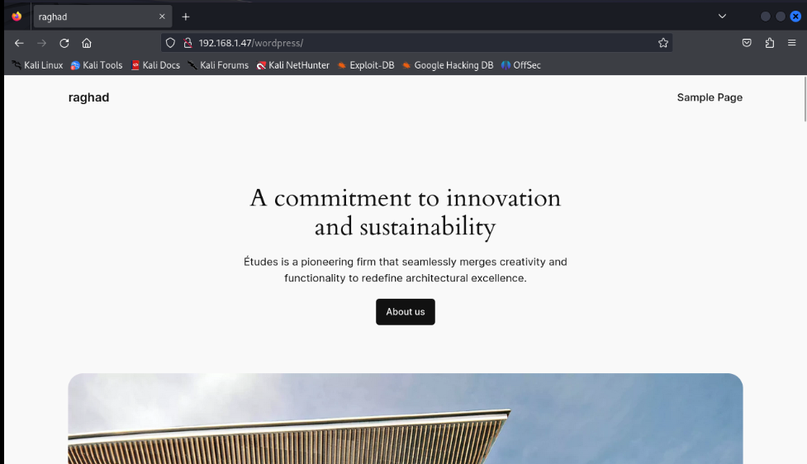

**so we used tool called gobuster used for directory and file brute-forcing.**

**It helps in discovering hidden paths on web servers to find the possible pages using common.**

**dir for discover hidden paths, directories, or files directories path**

**-u to tell where is the pathes to search.**

**-w used common names known for pathes.**

**-o to save the result in a file**

**txt wordlist which contain the common page names that used in many website.**

**It showed many page pathes so we accessed them .**

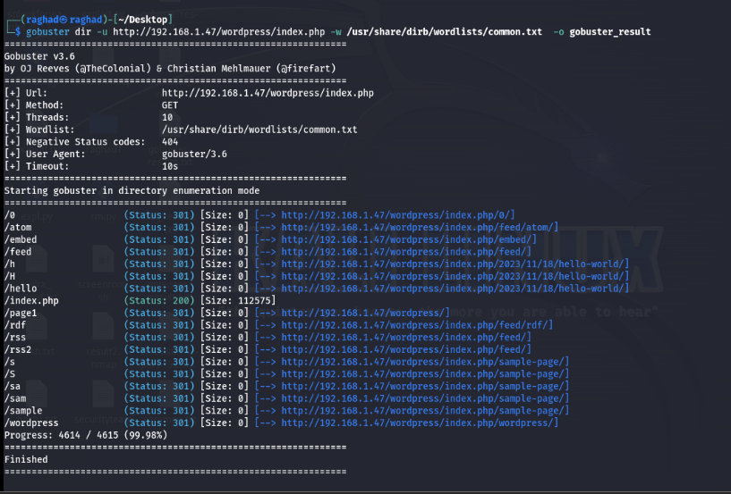

**When we accessed this page.**

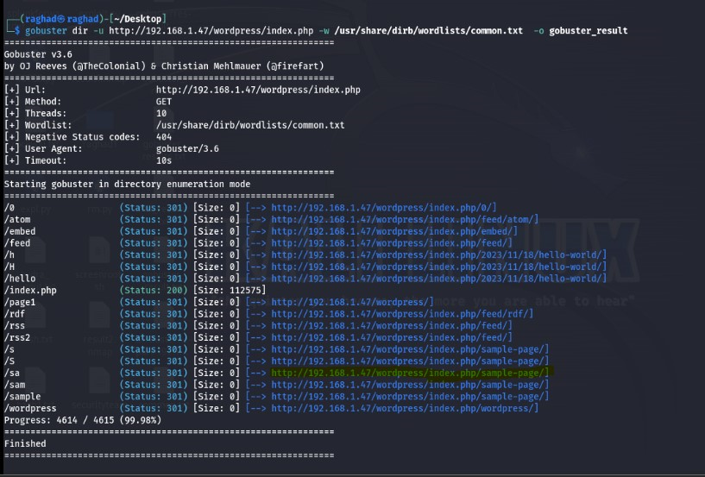

**It show us that there is a user called raghad so we tried to access it from another path we found in the gubuster result.**

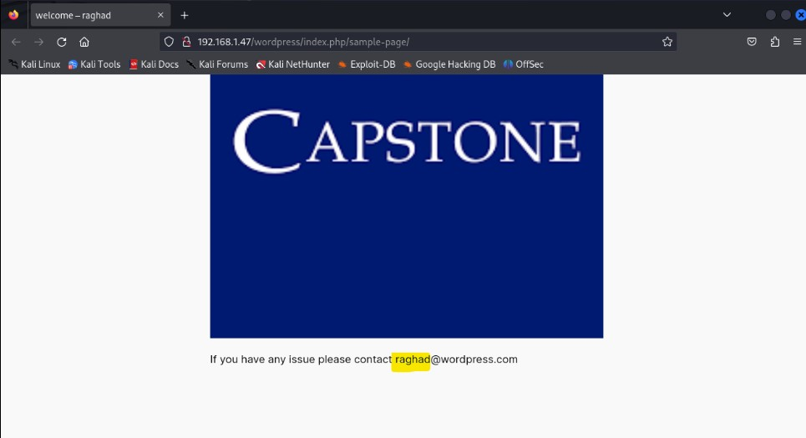

**In the wp-login.php page we entered the user name raghad and the password 123 and the result was incorrect password so that tell us that there a user called raghad.**

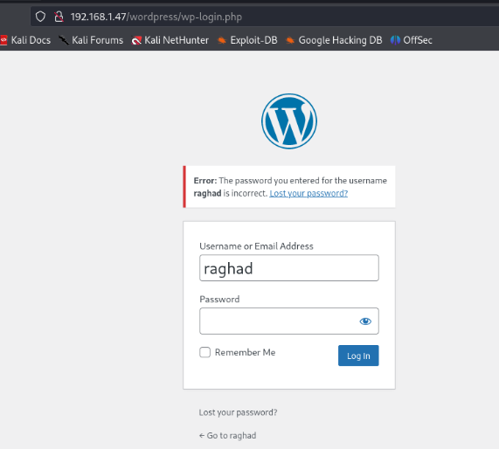

**Then we used burp suite tool to intercept the request when we logged in. after that we send the result to intruder section.**

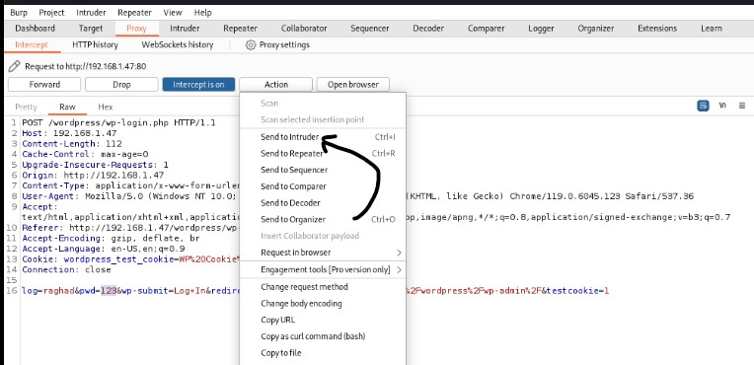

**We sellected the password to make brute force to it .**

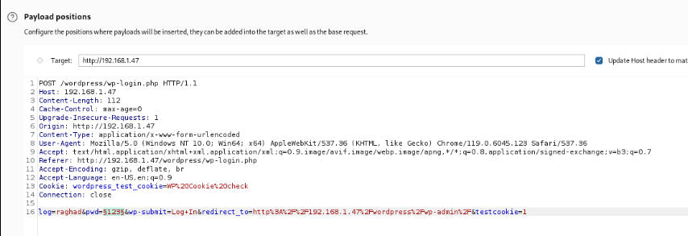

**We moved to payloads section and choose the rockyou.txt wordlist that contain many known passwords.**

**The result was that we accessed as admin to the website, so we tried to found if there is anything suspicious.**

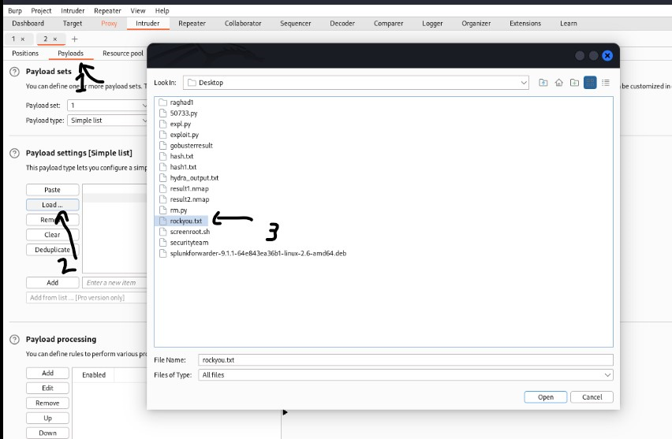

**We found the password is “password123”**

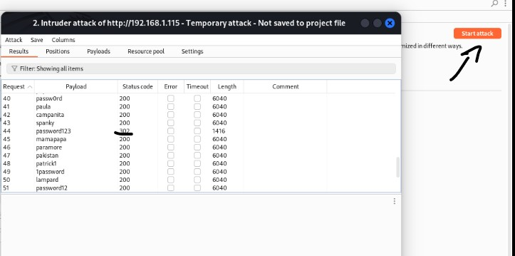

**So we tried to access it using this password.**

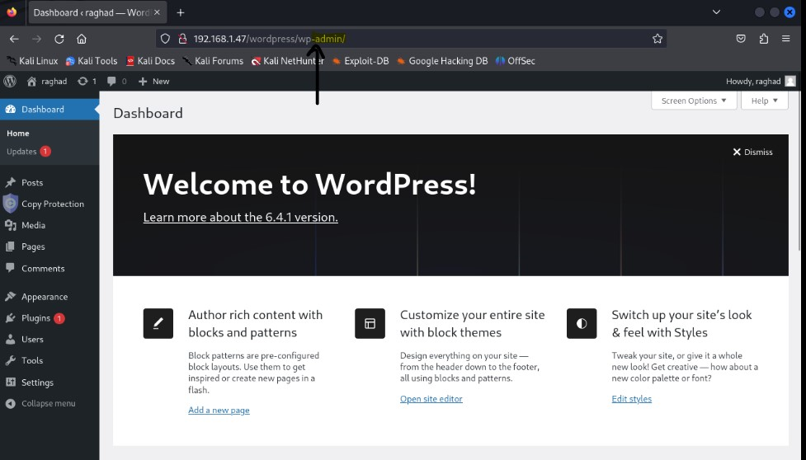

**We found that there is the plugin Secure Copy Content Protection that needs to be update which is a feature that provide restrict access to specific content or protect it from unauthorized copying, downloading, or sharing, like the source code .**

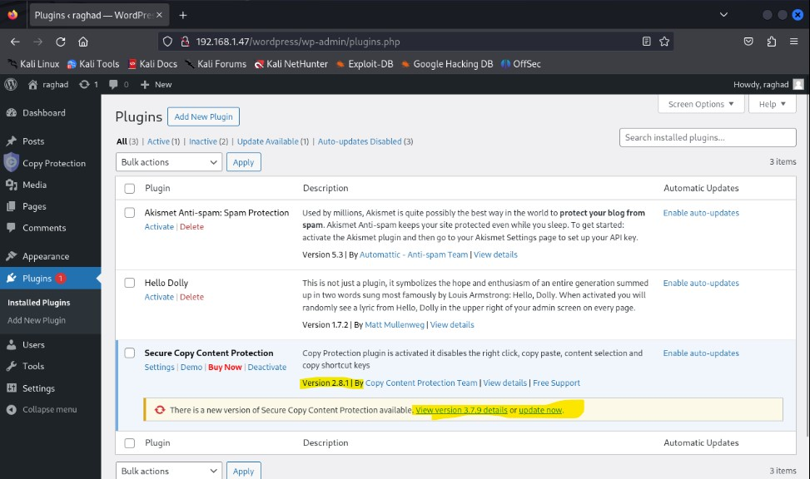

**So there is here a vulnerability talk about the current version in the website.**

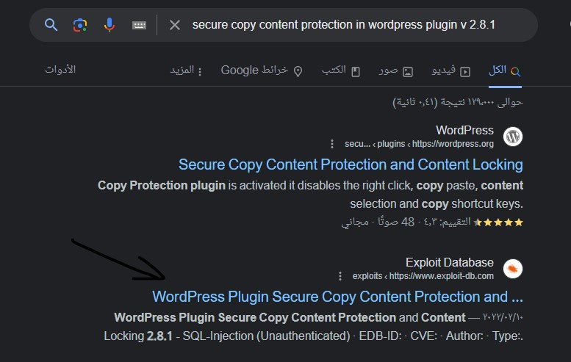

**So here is said that the vulnerability caused SQL-Injection.**

**And there is a script that we uploaded to use it to check for this vulnerability.**

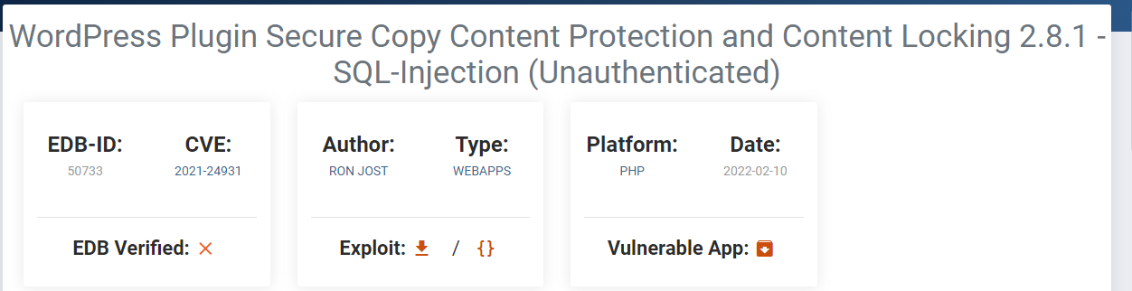

**The script**

**Details about vulnerability**

**The vulnerability happened because The plugin does not Sanitization and validate the sccp_id parameter of the ays_sccp_results_export_file AJAX action**

**Which is available to both unauthenticated and authenticated users before using it in a SQL statement and that Couse SQL injection.**

**By This vulnerability the attacker if he authenticated or not will be able to alter the SQL query used in the AJAX action.**

**It has three command line argument the ip of the target, the port that running the wordpress and the path for the wordpress**

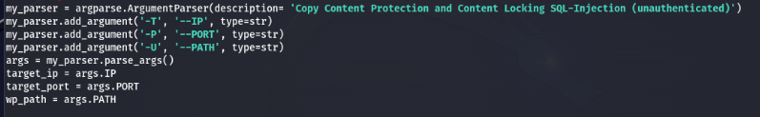

**Then it will print the starting time of the attack**



**The exploitcode_url store the URL (the sqlmap command,the url for the target,its port )and where the ajax action ays_sccp_results_export_file is ,it also have the vulnerable parameter sccp_id[]=3)* that’s mean that it terminate an existing SQL query or comment the query and then specify that the output is in json format .**



**After giving the argument and running the script it will ask to choose the sql option as a result of our injection by give the specific one for it and this is the list**

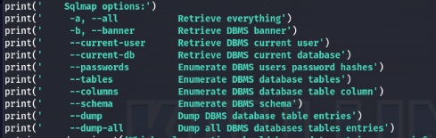

**Then it will add it to the exploitecode_url and --answers="follow=Y" will tell the script to automatically answer with yes if the sqlmap ask for anything that required users answer**

**The - - batch –v 0:**

**The - - batch is to run without need for user interaction and to not ask user for anything,**

**–v 0 : is the verbos level to tell that its need the minimal output**



**Run the sqlmap command that is in the exploitcode variable and then print the time when the exploit is finished.**



**We run the script and used the argument –h , to help us to specify what to write**

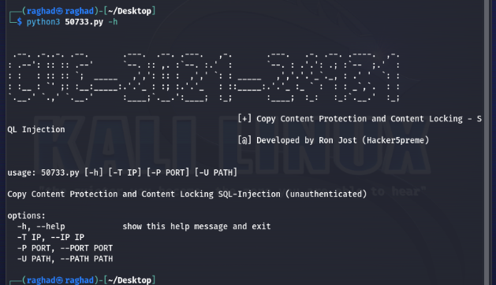

**We saved the result in a files**

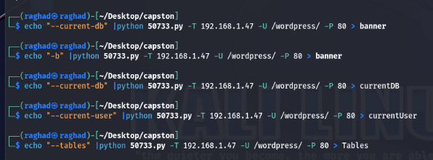

**We run it –T to specify the ip of the victim , -U to specify the path of wordpress –P to specify the port that running the website**

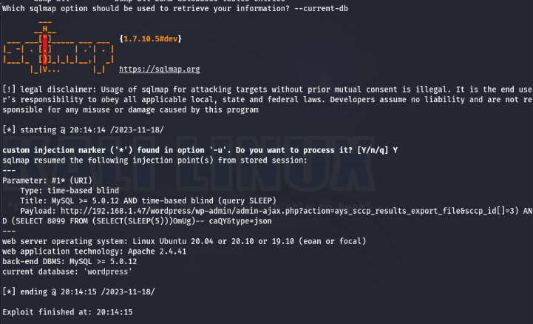

**The - - current-user gave us the current user of the data base.**

**The current user is raghad5 who can access the database of this website.**

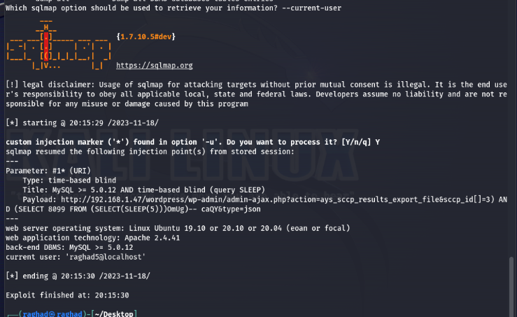

**When used -–tables it gave us the tables that inside the wordpress database and the information_schema  
and that was the result.**

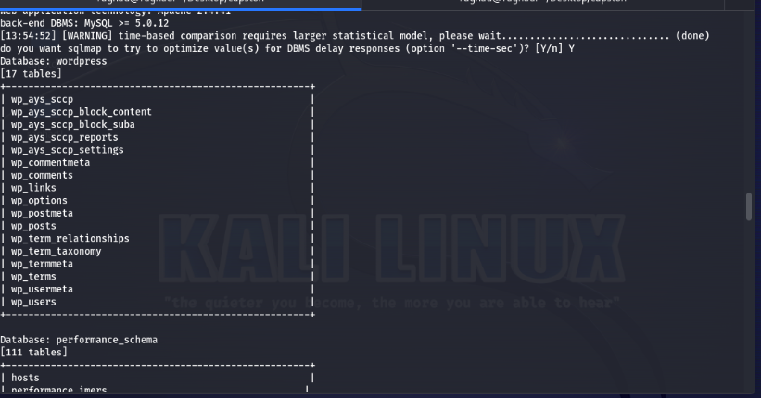

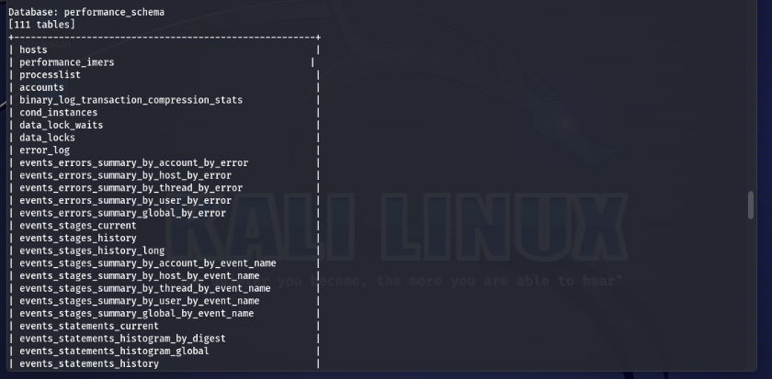

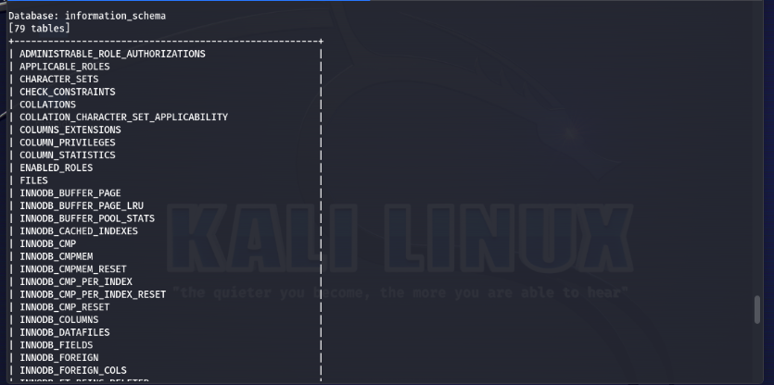

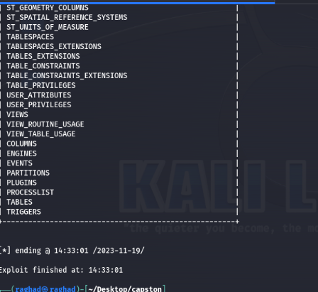

**When we tried -–passwords to get the passwords hash it didn’t work because the SQL injection is time-based which depending in the delay which will slowing down the application response time, and retrieve the passwords hash required more than 40 sec delay in our case so it could being detected by security monitoring systems, as abnormal delays in application responses and can be flagged as suspicious behavior.**

**The SQL injection point not being exploitable for password retrieval so if we had the current user of this database we can try to connect to the MySQL service using that user which is ‘raghad5’.**

**So, when we tried to access remotely it asked for a password,**

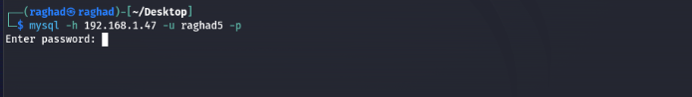

**Using a tool called hydry which help to make a brute-force attack using a list of common passwords**

**In this command we used hydra**

**-l for the username**

**-P for the list of the passwords**

**And the service name which is mysql and its IP and running port**

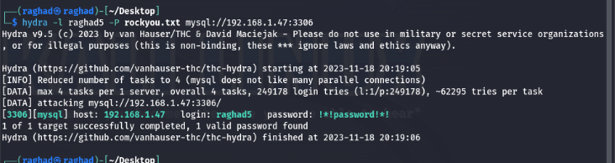

**And the password is ‘!*!password!*!’**

**Then we tried to accessed mysql using the username ‘raghad5’ and that password.**

**And we had login successfully , then we used the SHOW DATABASES; command to see which databases can be accessed from the user ‘raghad5’ and we found a DataBase called ‘ssh’.**

**So we accessed it using USE ssh; command and we show its tables using SHOW TABLES; then we found a table called ‘users’**

**So we used SELECT * FROM users;**

**command to view all the content of this table and we found a user called ‘yara’ and its hashed password.**

**We toke the password hash and tried to crack it.using jhon tool which allow us to crack the hashes using a list of passwords.**

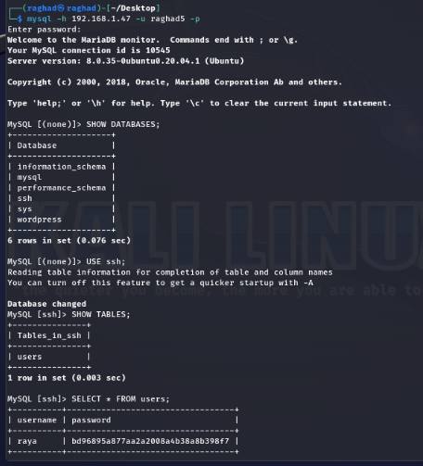

**We toke the password and the username separated with :, and stored it in a file called hash.txt using echo command**

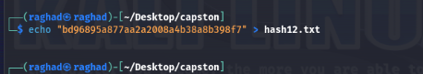

**We used john which is a tool that will crack the hash of the password without knowing the type of the hash by choosing -–format=dynamic and then choose the -–show display debug information and the file that contain the hash of the password.And it gave us the password which is ‘123zaq**’,**

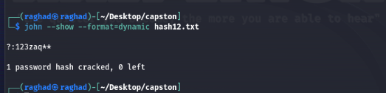

**Then we used it to access the server using ssh connection and it successfully connected to the machine with user ‘raya’.**

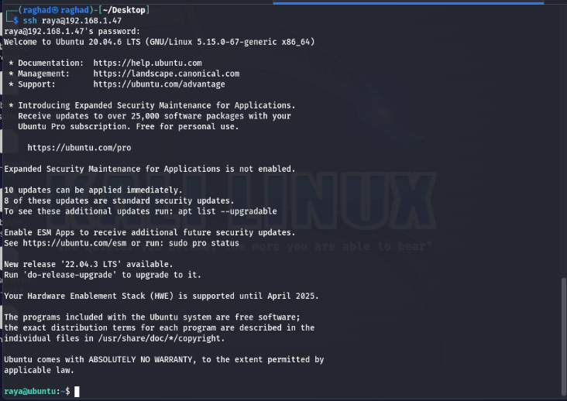

**Second we started with the "Ubuntu" server and scan it using nmap.**

**-sV: to determine service/version information in the open ports.**

**-sC: Show the running default scripts.**

**-p-: Scan all 65535 ports.**

**-Pn: Treat host as online.**

**-o: Save the output of the nmap in the file named result1.nmap.**

**-O: to know the operating system.**

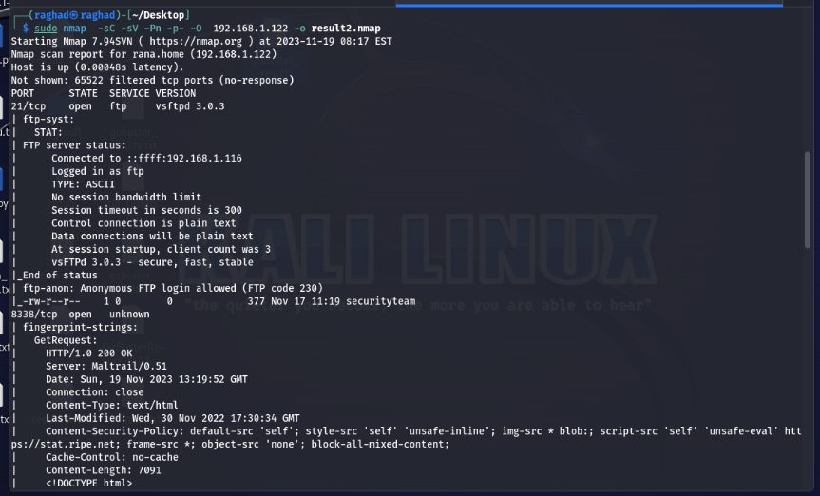

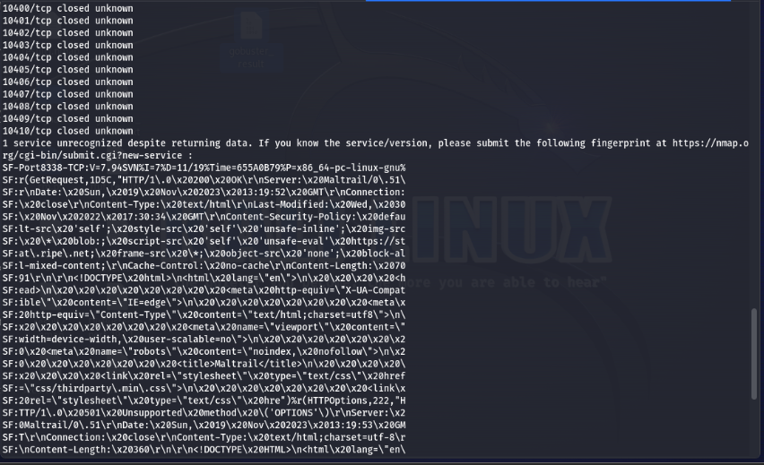

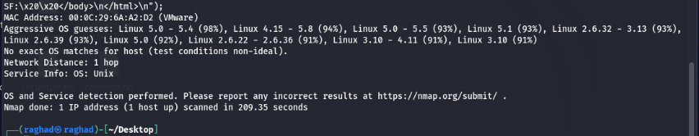

**The 8338 port which its service unknown and has a mailtrail server.**

**port 8338 is a maltrail server with version 0.52 which is a malicious traffic detection system.port 21 Running vsftpd 3.0.3 which is FTP service that allows anonymous login.Ports from 10400 to 10410 are closed.**

**Also it show that the operating system could be from Linux distribution.**

**Here we had a server called Maltrail/v 0.52 running in port 8338 ,the Maltrail is an open-source network traffic security monitoring tool designed for intrusion detection. It focuses on the detection of malicious activity within network traffic.And the ftp is allowed us to transfer files between server and client also here we can login with user anonymous without a password and it shows that there is a file called securityteam that we can read it if we accessed the ftp using the anonymous user.**

**We tried at first to login to the ftp sever and get the file to our machine .**

**We logged in successfully then we get the file to our machine**

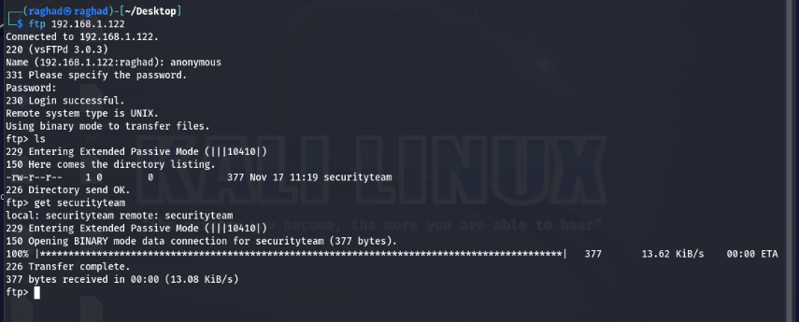

**When we read the file it showed that there is encoded message**

**And we tried to guessed its type to decoded it**

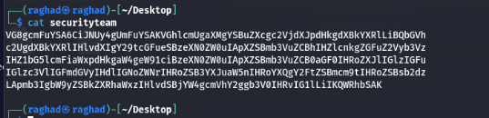

**We used the cyberchef website that has a feature called magic this feature help to guesses the type of the message wither its hashed , encrypted, or encoded by any type of these techniques .so when we used it .it showed that it could be a base85 encoded text**

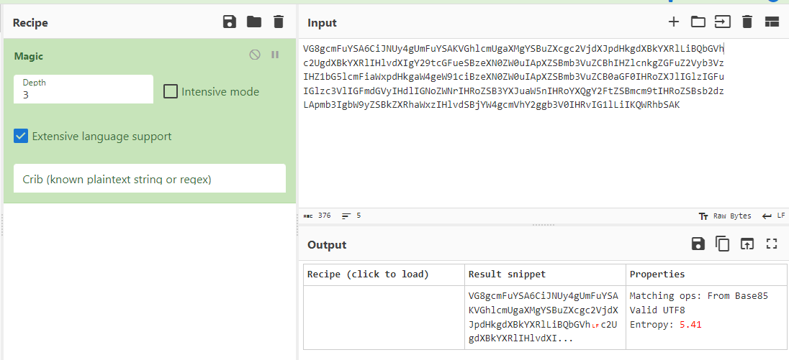

**When we used the base86 to decoded the text it didn’t gave a clear text**

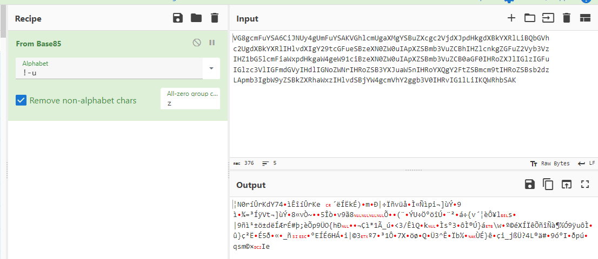

**So we tried another base type like base64 which gave us a clear text**

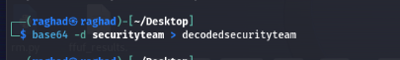

**The message showed that it is from Adam that could be a admin for the security in the company and its send to rana that could be the owner of the system and the message showed that the system need to security update according to the one of the log file that shows an alarm that could cause to the breach of the security.**

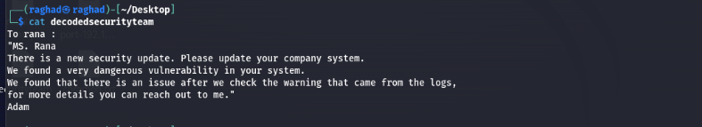

**So then we tried to access the maltrail server using its port 8338.**

**When we accessed it using the IP and the running port we found that it’s not the latest version of this web application.**

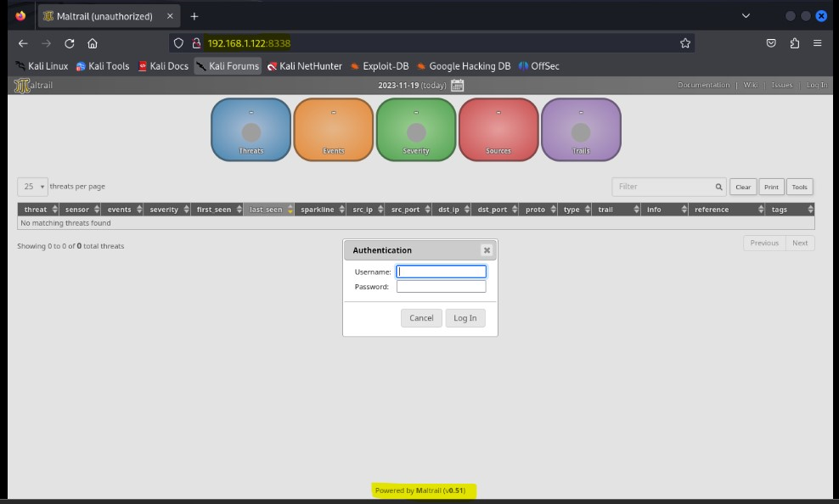

**So we searched about this version and we found a command injection vulnerability which injecting arbitrary OS command and can executed remotely without authentication that allowed us to make a revers shell.**

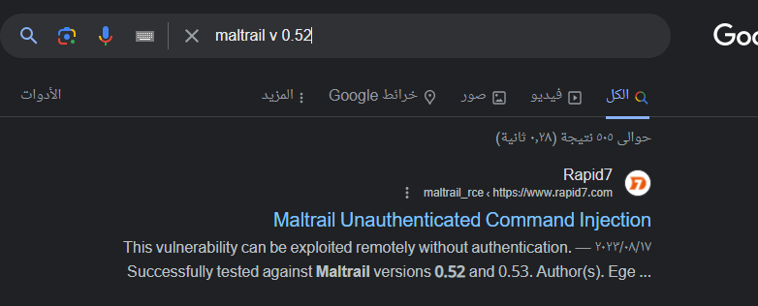

**We found a Python3 script on GitHub that prompts the user for the attacker's IP address, listening port, and the target URL where Maltrail is running. The exploit script requires three arguments: the listening IP, listening PORT, and the target URL. The script will make a payload that, when executed, will create a reverse shell connection back to the attacker’s machine.**

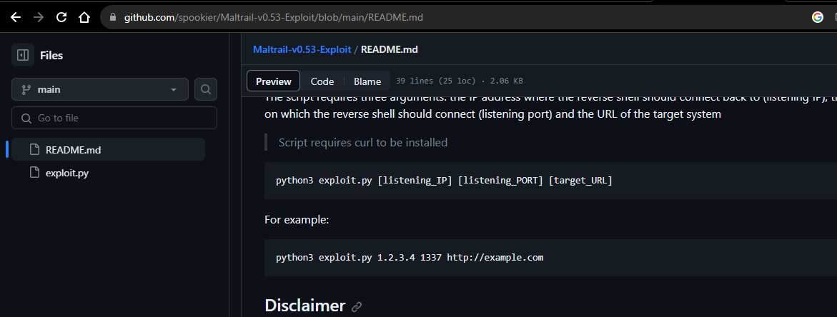

**The script**

**Details about vulnerability**

**In version 0.52 of maltrail the username of the login page doesn't check the input and that allow the attacker to inject OS commands.**

**So the vulnarability uses the subprocess.check_output() function to execute a shell command that logs the username.**

**The exploit creates a reverse shell payload encoded in Base64 to bypass potential protections like WAF, IPS or IDS and delivers it to the target URL using a curl command.**

**Then it will executed on the target system and making a reverse shell connection in the attacker's IP and its listening port**

**First it import the 3 libraries sys, os, base6**

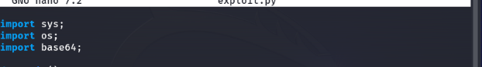

**In the main function its define 3 variable (listening_IP, listening_PORT, and target_URL) With non value .then checks the correct number of command-line arguments if they are not then it will prent a message and then will exit**

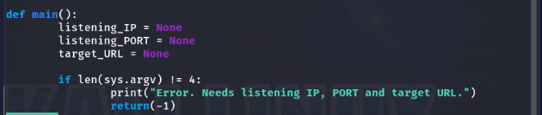

**Assigned the given command lines argumants to the variables then print a message, after that It will use the values as argumantes to send them to the curl_cmd() function**

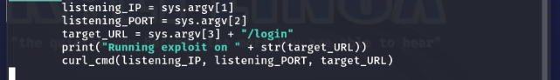

**The curl_cmd Useing payload python command it**

1. **imports the required modules: socket, os, and pty It then creates a TCP socket and**
2. **Establishes a connection to the attacker IP address (my_ip) and its listening port (my_port).**
3. **duplicating file descriptors and linking them to the socket to establishes communication channel between the attacker's machine and the spawned shell on the target server**

**5- it uses pty.spawn to initiate an interactive shell (/bin/sh)**

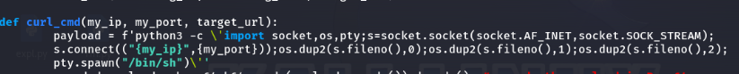

**Encode the payload and then decode it to ensure that it is represented in a way that can be safely transported and executed in the command. The curl command will make a post request to the target URL and the payload will inject in the username parameter and decoded it using base 64 and run it in sh to execute shell command Execute the curl command using os.System**



**First we opened the listening port 4444**

**-lnvp**

* **-l: This option for listening mode and waiting for incoming connections.**
* **-n: This option not to perform DNS resolution on incoming IPs, displaying them as numbers.**
* **-v: This option to providing more detailed information about the connection.**
* **-p: This option specifies the port number.**

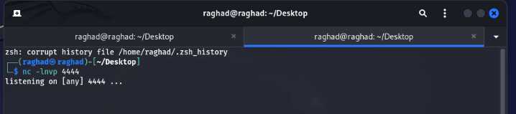

**Run the python3 script with our IP, our listening port and the URL for the target server.**

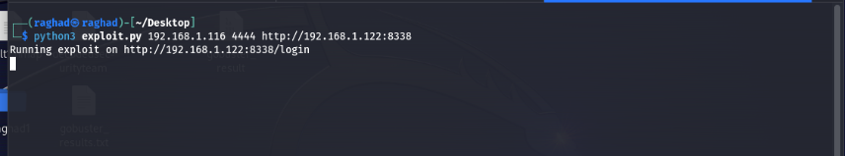

**That gave us a shell back to our machine and we can access the**

**Server.**

**And we could read the /etc/passwd file in the server .**

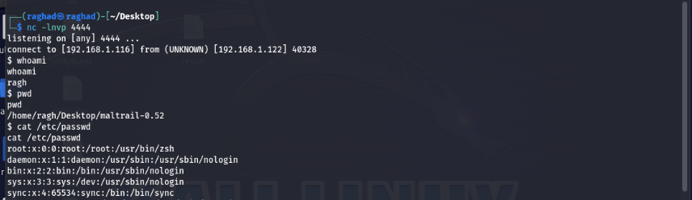

**Then we tried to access the log directory to search for any warning message.**

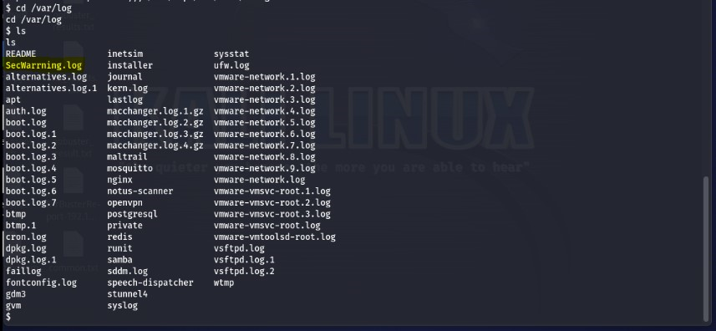

**We found this unusual file and we tried read it and we found four warning messages.**

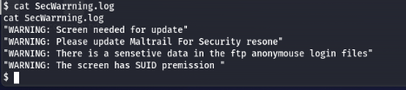

**One of them tells that we need to update the screen. The screen command is a terminal multiplexer that allows you to create multiple sessions within a single terminal window.**

**And the other tells that the screen has a SUID permission.**

**So we used command to know its version. Which is show that it is not the latest version.**

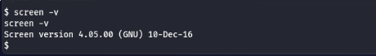

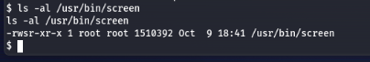

**When we searched about this version we found that there is a vulnerability that could lead to local privilege escalation.**

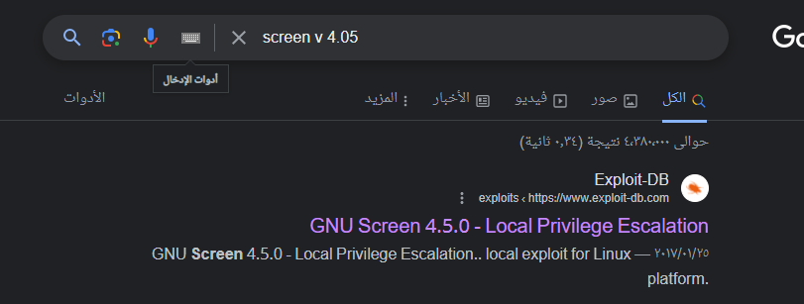

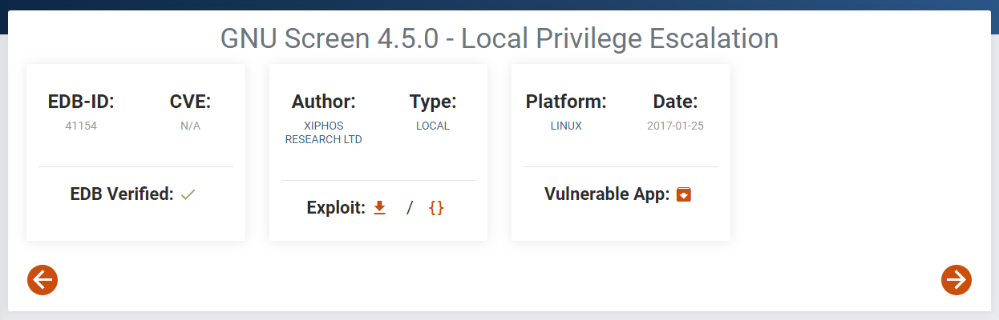

**So we downloaded the script to explore this vulnerability.**

**The script**

**Details about vulnerability**

**Its vulnerability that allows local users to modify any files and consequently gain root privileges by take advantage from improper checking of logfile permissions by this the file would be created with the same permission as the root. It used to create any files with root permissions containing any content. If the Screen program is owned by root, the files created will be owned by root as well.**

**The exploit script have three main part:**

**Creating a Shared Library (libhax.so):**

**• The script create a shared library named libhax.so in the /tmp directory. • This library contains code that will be executed with root privileges when loaded.**

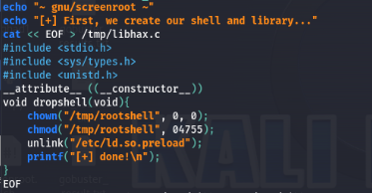

**Creating a Root Shell (rootshell):**

**• Next, the script creates a C program named rootshell in the /tmp directory.**

**This program will be compiled into an executable binary that runs as a setuid root shell when executed.**

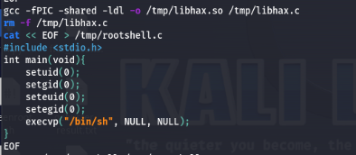

**Creating ld.so.preload Exploit:**

**• The script changes the directory to /etc**

**• umask to 000 :**

**this command allowing full permissions on any files created in this directory.**

**• Then use the screen command to create file in the /etc/ld.so.preload**

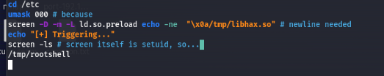

**Now we need to upload the script in the machine remotely after we downloaded it in our machine.**

**So we opened a web server in the directory of our machine the script is inside it.**

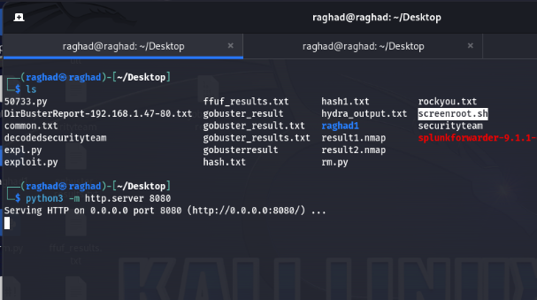

**Then we used wget command to download it in the victim machine. by specifying the port that opened which is 8080 and the wanted file .**

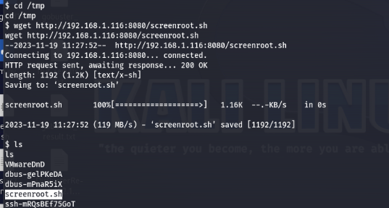

**We changed its permission to be executable**

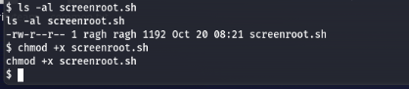

**Then we run it, it made us a root user which is a very dangerous.**

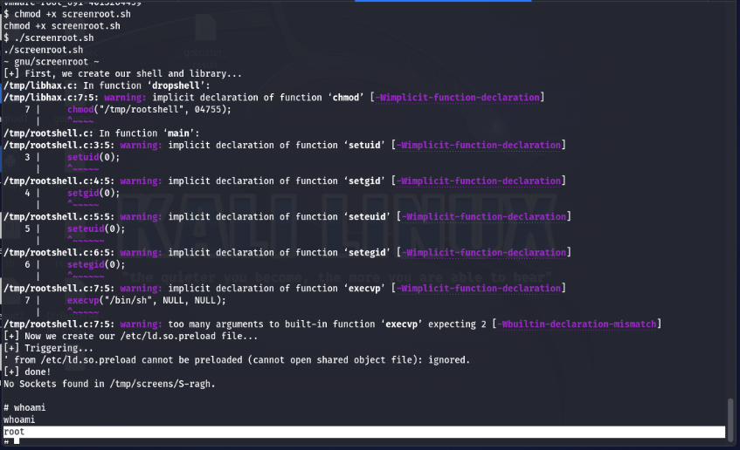

**It made a user that not in the root or sudo group to become the root.**

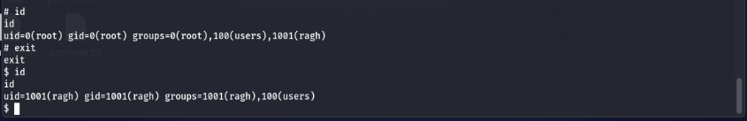

**Recommendations and Mitigations**

**In ubuntu server:**

**WordPress Website:**

**Vulnerability:**

**SQL Injection in WordPress Plugin:**

**The vulnerability happened because the plugin does not Sanitization and validate the sccp_id parameter of the ays_sccp_results_export_file AJAX action which is available to both unauthenticated and authenticated users before using it in a SQL statement and that Couse SQL injection.**

**Weak Passwords: The easily guessable password like "password123" can lead to unauthorized access to the wordpress which is very dangerous when it is an admin.**

**Brute-Force Attack: Successful brute-forcing of passwords indicates a lack of account strong password policies.**

**Mitigation:**

**Update the Copy Content Protection and Content Locking plugin to the latest version.because the new version has an Input Sanitization feature:**

**First it attempts to convert the 'sccp_id' values to integers using intval().**

**In cases where the 'sccp_id' is null, or contains unexpected data that cannot be converted to integers,**

**The code defaults to a pre-defined secure SQL query stored in $shortcode_ids, employing esc_sql() to ensure safety.**

**Also, the esc_sql() function is applied to 'sccp_id', 'date_from', and 'date_to' parameters to sanitize and escape special characters to sanitized inputs into the SQL query.**

**This will prevent potential SQL injection risks by sanitizing the user input or reverting to a pre-set secure SQL query**

**Enforce Strong Passwords:**

**Implement policies requiring complex and strong passwords.**

**Enforce Strong Password Policy:**

**Implement a policy requiring complex passwords (combination of upper and lowercase, numbers, and special characters).**

**MYSQL Service**

**Vulnerability:**

1. **Weak Passwords: The easily guessable password like "!*!password!*!" can lead to unauthorized access to the MySQL database.**
2. **Brute-Force Attack: Successful brute-forcing of passwords indicates a lack of account strong password policies.**
3. **Using MD5 hash for the passwords that could easily cracked**

**Mitigation**

1. **Change Passwords:**

**Change passwords immediately to complex.**

1. **Enforce Strong Password Policy:**

**Implement a policy requiring complex passwords (combination of upper and lowercase, numbers, and special characters).**

**Configure MySQL to enforce these policies for all user accounts.**

1. **Use strong hashing like sha512 for the passwords stored in the databases.**

**In rana server:**

**FTP Service**

**Vulnerability:**

1. **Unauthorized Access: Any user can access and get files from the FTP server without proper authentication.**
2. **Sensitive Data Exposure: Access to files from the security team could lead to information to be expose.**

**Mitigation:**

1. **Disable Anonymous Login:**

**Access the FTP server's configuration file.**

**Disable the "anonymous login" in the configuration.**

1. **Make User Authentication:**

**Configure the FTP server to require user credentials for accessing files.**

1. **Enable Logging and Monitoring:**

**Enable logging file for FTP access and review access logs to detect any unauthorized activities.**

**Maltrail Server**

**Vulnerability:**

**The username of the login page doesn't check the input and that allow the attacker to inject OS commands.**

**So the vulnerability uses the subprocess.check_output() function to execute a shell command that logs the username.**

**Mitigation:**

**You can update the Maltrail to its latest version and if you can’t for some reasons.**

**You can set the shell to false, that’s will prevent making a reverse shell and that what is the update version did.**

**And this is where exactly happened in the code.**

**The vulnerability has been solved in the new versions by setting shell=False, preventing shell injection attempts and enhancing the security of Maltrail systems.**

**This mitigation technique restricts command execution within a shell environment, to prevent the vulnerability's exploitability**

Line 366 (vulnerability) <https://github.com/Youhoohoo/maltrail-iie/blob/master/core/httpd.py>

Line 399 (mitigation) <https://github.com/stamparm/maltrail/blob/master/core/httpd.py#L399>

**Screen tools**

**Vulnerability:**

**Privilege Escalation Vulnerability that allows local users to modify any files and consequently gain root privileges.**

**Systems running Screen version 4.5.0 with setuid root.**

**Mitigation:**

**Reduce Permissions: Avoid using setuid root if it is unnecessary.**

**Update the screen to the latest version that adding permissions check for the logfile name: The code change involves checking if the screen logfile can be opened for writing and taking appropriate action if there are any issues, preventing the vulnerability in the script. This change would avoid the security issue by ensuring that the logfile is writable**

**Part [3] Defensive Cybersecurity**

**Complete detailed analysis for the systems, showing all information and traces, or artifacts you managed to gather.**

**Ubuntu server**

**We found some traces in the log files using splunk tool, there was a lot of failed login attempts to mysql server from the user raghad5 remotely**

**Which can consider that someone tried to make a brute force to the server, because this user said that he didn’t access his account remotely.**

**After that we discover that his password was very easy to guesses.**

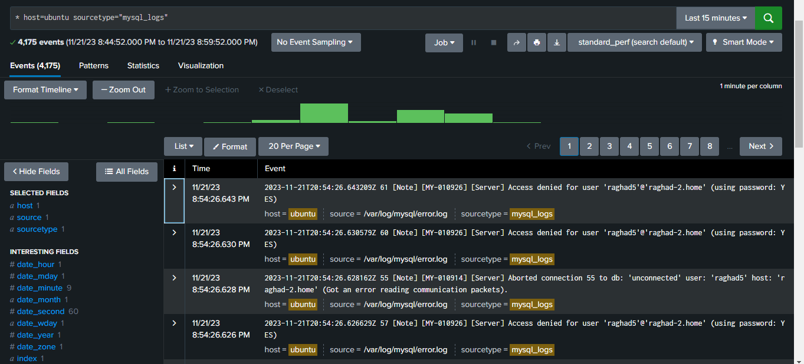

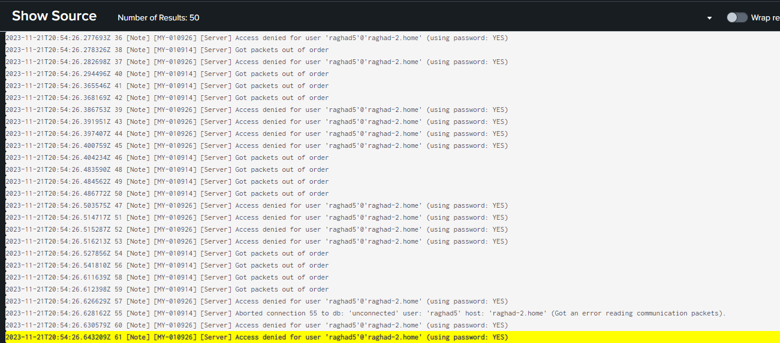

**When we asked the user raghad5 about his permission to the database we found that he has a full access to the ssh users database.**

**So we searched in the auth.log for any attempt to access using the ssh connection.**

**Then we found that there was a session from unknown ip and not a part of our company which is ‘192.168.1.116’ which managed to accessed our network and made ssh connection using the username of one of the employee account called raya.**

**We also discovered that the password of raya was stored its hash using MD5 which consider very weak hash.**

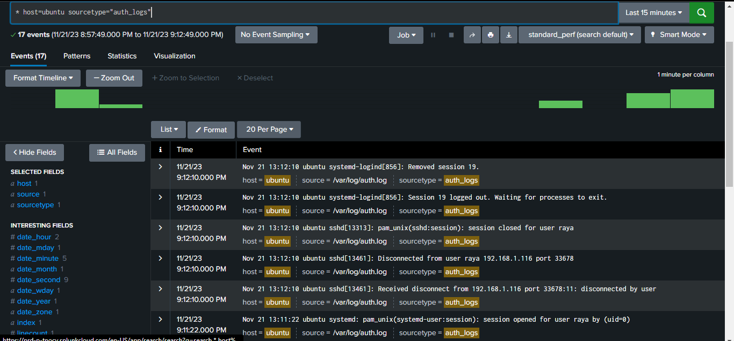

**The attacker made a scan for this server at first that’s way he knew that there was an open port for ssh connection and MySQL.**

**Also the raghad5 user have an access to the wordpress database which and he is an admin to the website so we searched about the apache logs and we found that there is an sql injection using the sqlmap tool by taking advantage from the 'sccp_id' parameter in the Secure Copy Content Protection and Content Locking version 2.8.1 that is not sanitized, and after accessing the wordpress site we discovered that:**

**1. The admin has a weak password.**

**2. The Secure Copy Content Protection and Content Locking version 2.8.1 is not the latest version and caused a sql injection.**

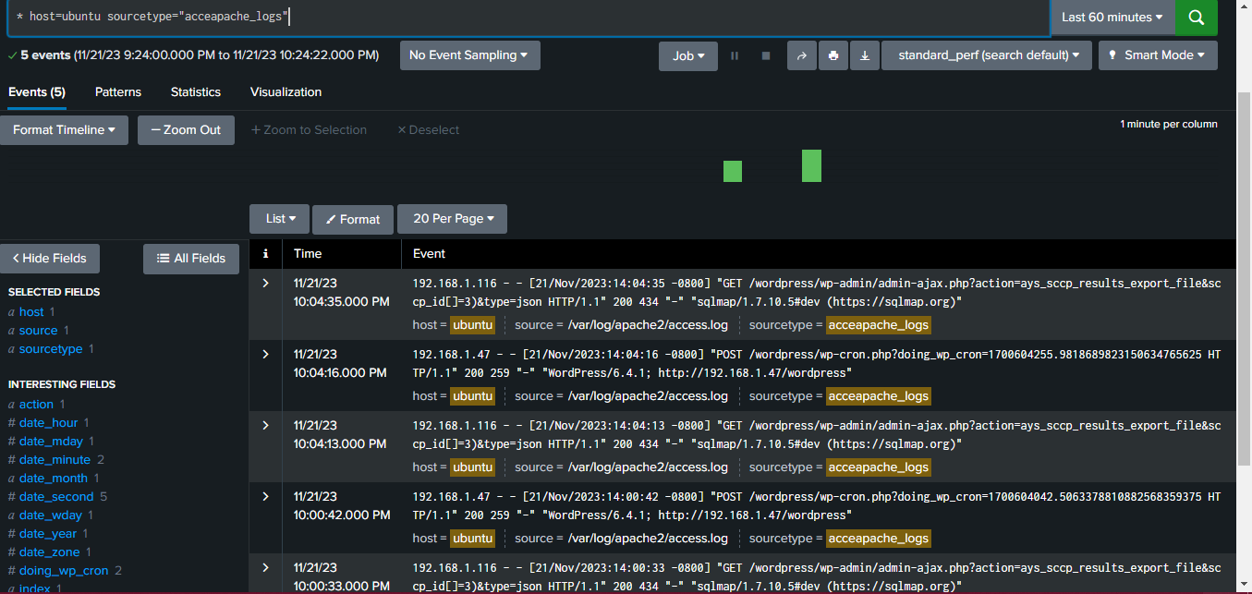

**And it’s hard for the attacker to know that the plugin is vulnerable because the source code is hidden. So we think that he know because of:**

1. **He made a brute force and access the admin page because he has a weak password.**
2. **Or he guessed that because the plugin is active in the system.**

**This what happened when we click right-click to see the source code.**

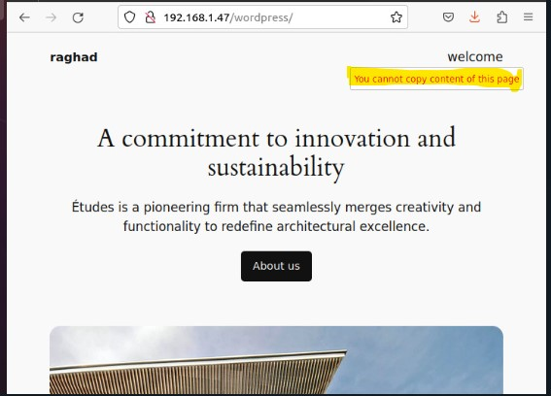

**Note: all these vulnerability happened in the same hour which mean that is a full attack to access the system.**

**Rana server**

**We found some traces in the log files using splunk tool, we found that there is an anonymous login from the unknown IP “192.168.1.116”, which mean that the attacker managed to access the network, and the ftp had a file from the security team which hasn’t to be in this path and the attacker downloaded it.**

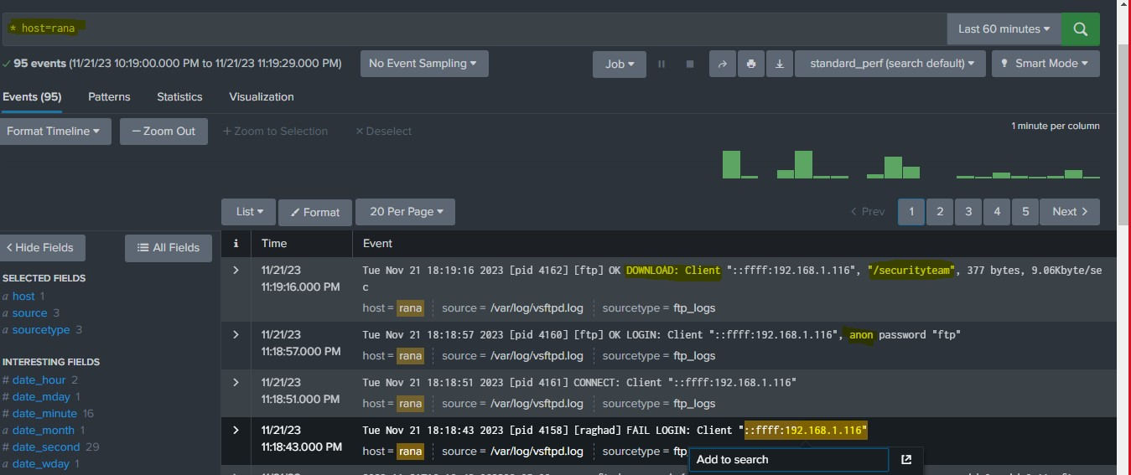

**We found that the file has a sensitive information encoded with base64 technique, after the owner permission we read the file and found that the file information tell there is a log with warning information.**

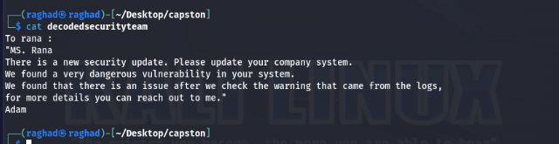

**So when we searched for the warning message we found this in the log.**

**The warning tells that the screen need for update and has a SUID permeation which allow the user to run the tool as a root but its script will remain as a user itself , the maltrails need for update and it tells that the ftp needed to configure because there is a sensitive data shown to everyone.**

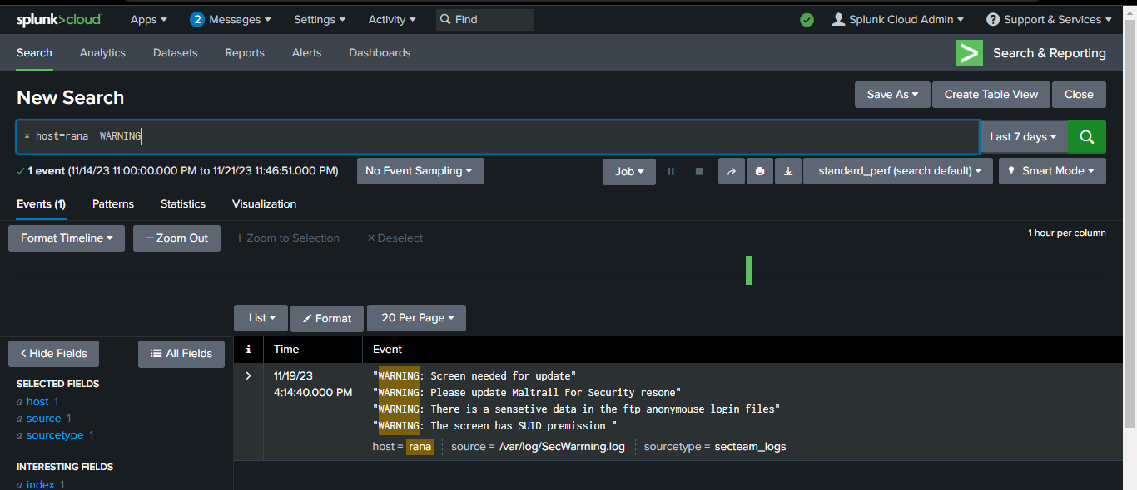

**After the owner permission we accessed the maltrail and we found that it is not the latest version and we discovered that this version could lead to Remote Code Execution because the username of the login page doesn't check the input and that allow the attacker to inject OS commands and if we get back to the source code we will found that the shell is set to true which allow the attacker to make a reverse shell using the os command injection.**

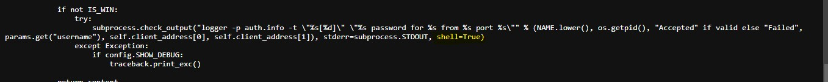

**Here we found that there is a session for the root that opened and closed whiteout knowing any command in the history of them and there is a failed login from the maltrail server which mean that it could work to make an attack with command injection. Also the screen vulnerability lead to privilege escalation and when we search for any track we found that there is file in the /tmp directory that has a script that take advantage of the screen vulnerability to make a privilege escalation and there is no indicator in the command history that the file was created from the user ragh but the user ragh is the user who run the maltrail server so it could be that the attacker made a privilege escalation remotely from the maltrail vulnerability**

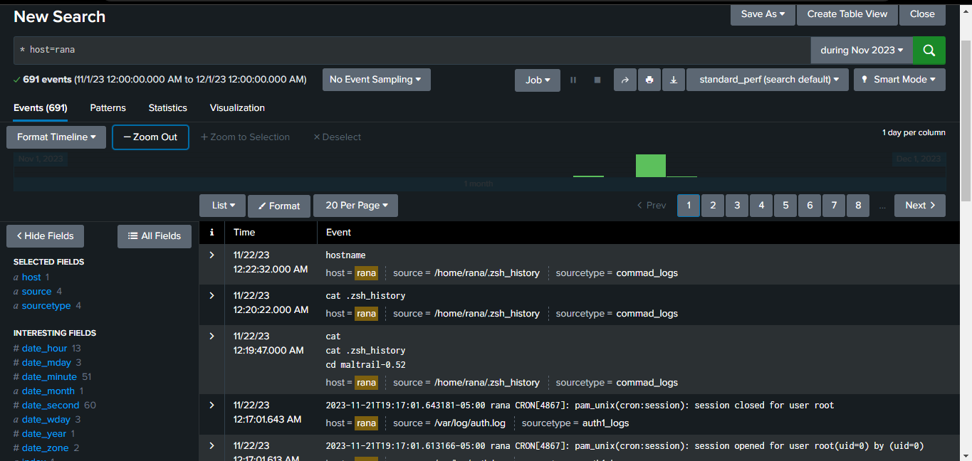

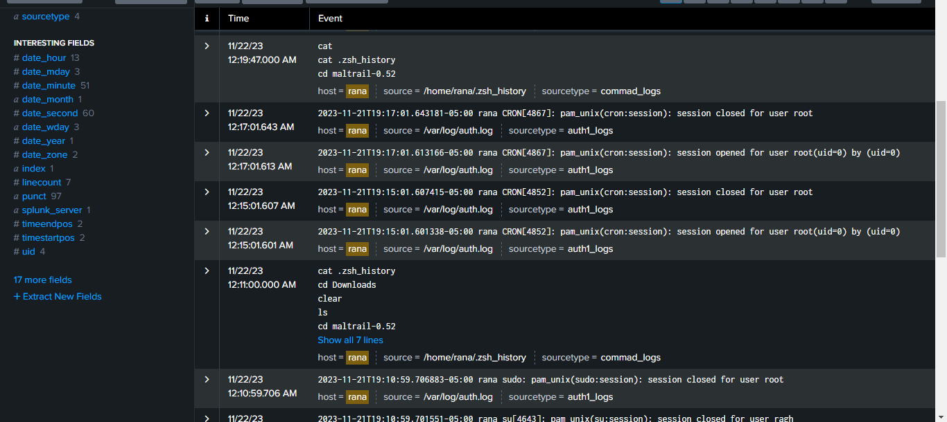

**There is no indicator from the logs that ragh and the root created these files.**

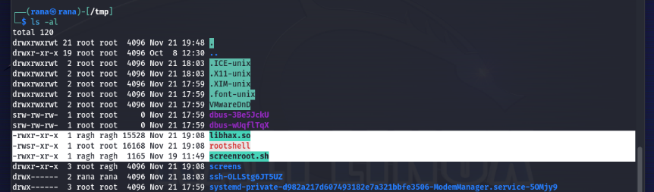

**This version of screen lead to privilege escalation.**

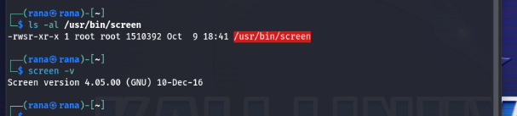

**The MITRE ATT@CK Navigator Mapping**

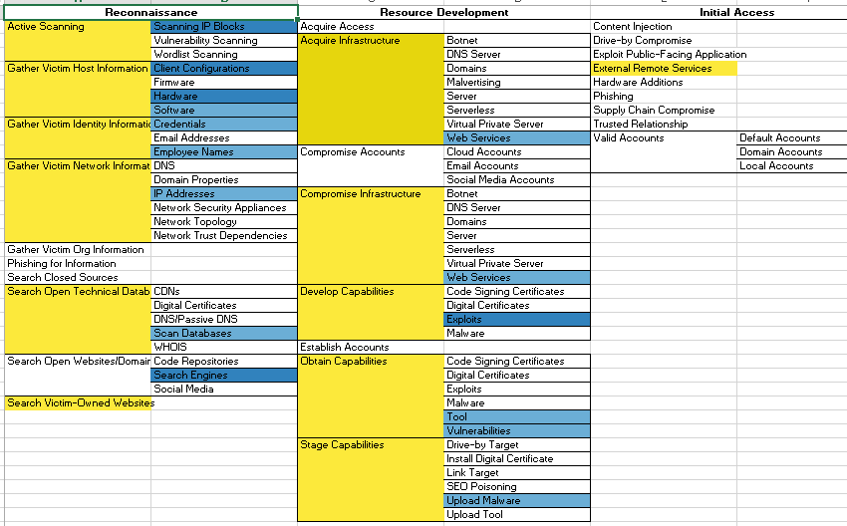

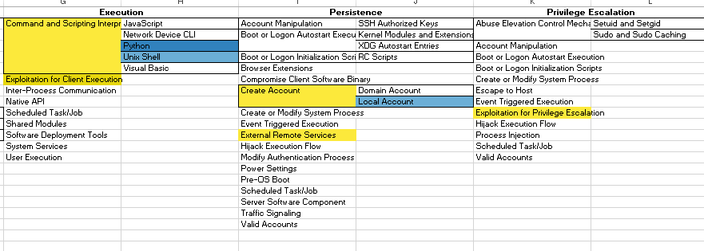

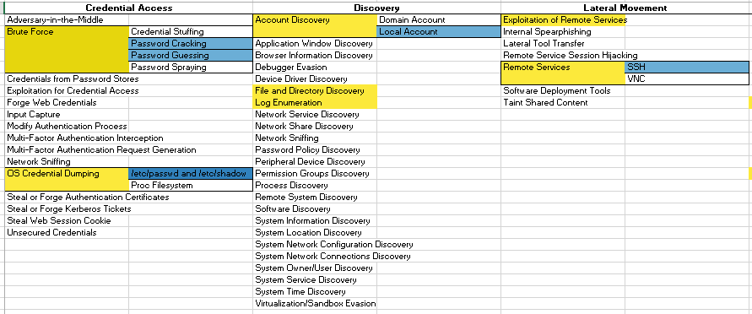

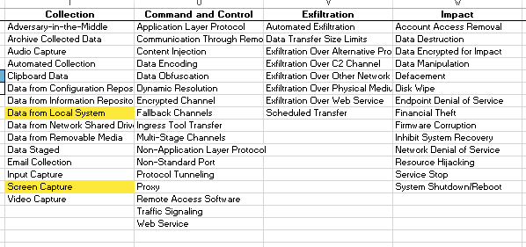

**Timeline of the incidents and the attack.**

**Ubuntu server**

| **Date** | **Time** | **Event Description** |
| --- | --- | --- |
| 2023-11-21 | 08:54 PM | Brute force attack to MYSQL server , a lot of number of failed login |
| 2023-11-21 | 08:58 PM | Access MYSQL with successful login |
| 2023-11-21 | 09:12 PM | Access with raya account using ssh connection |
| 2023-11-21 | 10:04 PM | Successful SQL injection to the wordpress website using SQLMAP |
| 2023-11-21 | 10:30 PM | Change the password of raya user (strong password) |
| 2023-11-21 | 10:45 PM | Change the password of the MYSQL server (strong password) |
| 2023-11-21 | 10:50 PM | Shutdown the wordpress website |
| 2023-11-22 | 12:00 PM | Limited the number of incorrect login attempts to the MYSQL Server. |
| 2023-11-22 | 12:05 PM | inforce Strong polices for the passwords to the ssh and MYSQL accounts |
| 2023-11-22 | 12:10 PM | Update the secure copy plugin in the wordpress and run the website |

**Rana server**

| **Date** | **Time** | **Event Description** |
| --- | --- | --- |
| 2023-11-21 | 11:18 AM | Successful login as anonymous to the FTP Server |
| 2023-11-21 | 11:19 PM | Successful Download to the sensitive file in the anonymouse files |
| 2023-11-21 | 12:17 PM | Opened session for the root user to 3 minutes then closed |
| 2023-11-21 | 12:20 PM | Found malicious file in the /tmp directory created by the root |
| 2023-11-21 | 11:30 PM | Find warning message about a vulnerability in screen tool |
| 2023-11-21 | 12:19 PM | Privilege escalation vulnerability from the user who run the maltrail server |
| 2023-11-21 | 01:00PM | RCE vulnerability in maltrail caused command injection |
| 2023-11-21 | 01:05 PM | Shutdown the maltrail |
| 2023-11-21 | 12:40 PM | Move the sensitive file to secure path |
| 2023-11-21 | 01:30 PM | Update the maltrail version |
| 2023-11-21 | 01:35 PM | Run the maltrail Server |
| 2023-11-21 | 01:40 PM | Configure the FTP server to be logged only with user and password |

**Documentation showing how you applied the needed fix or if you added any new security controls to eliminate the vulnerabilities in your environment**

**Ubuntu server**

**WordPress Website:**

**Update the admin “raghad” password**

**The password is set to be generated as a strong password**

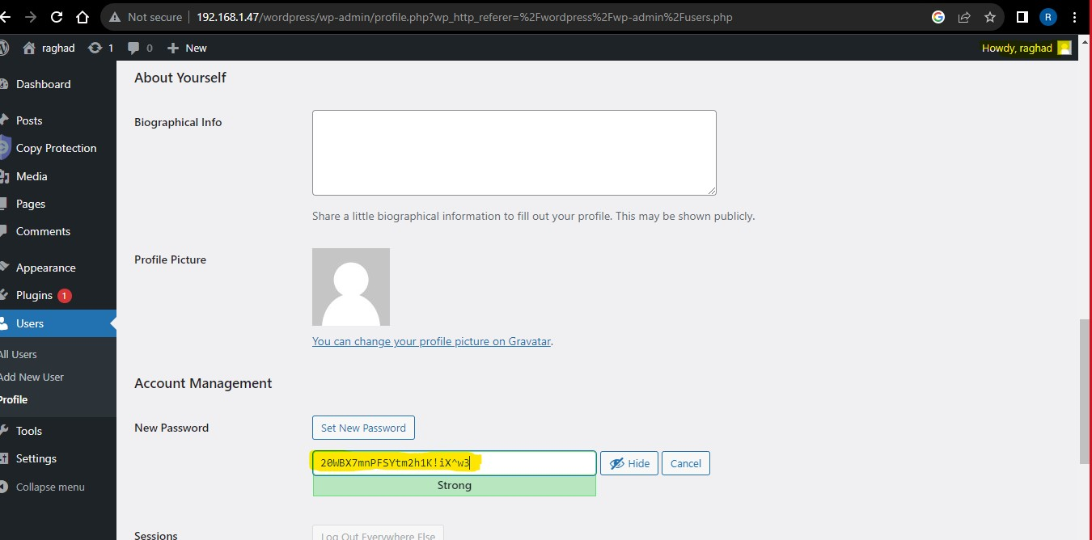

**Update the plugin with its latest version**

**The latest version is 3.8.0**

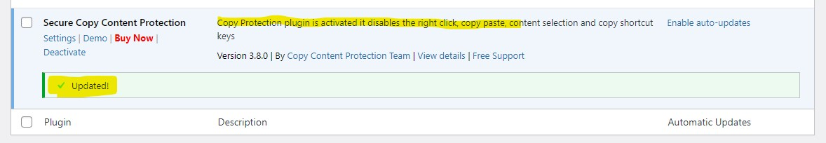

**MYSQL Service:**

**Change the password of raghad5 to be more complex:’ 12**ab**21**b1’**

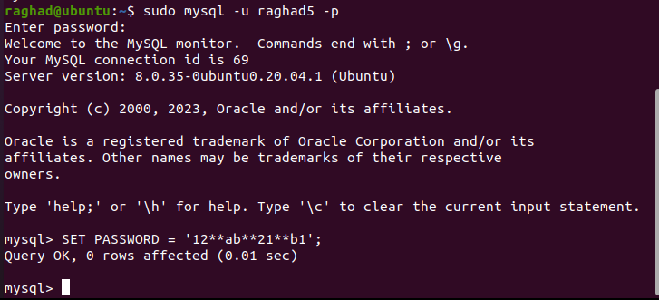

**Enforce Strong Password Policy:**

**Implement a policy requiring complex passwords (combination of upper and lowercase, numbers, and special characters).**



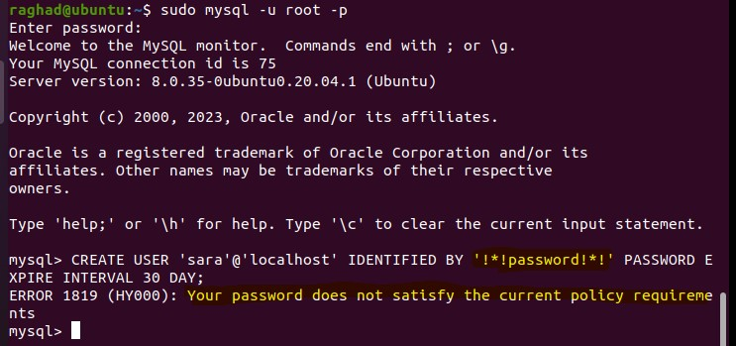

**Rana server**

**FTP Server:**

**Disable Anonymous Login:**

**Disable the "anonymous login" in the configuration.**

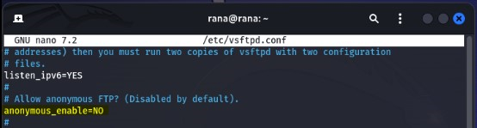

**Make User Authentication:**

**Require user credentials for accessing files.**

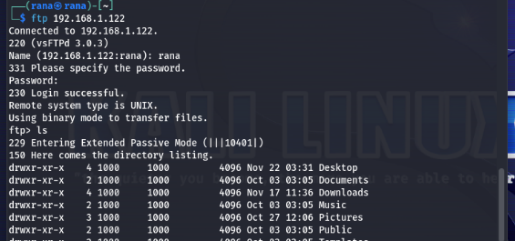

**Enable Logging and Monitoring:**

**Enable logging file for FTP.**

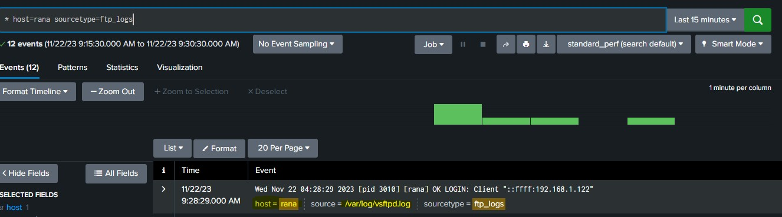

**Maltrail Server:**

**You can update the Maltrail to its latest version.**

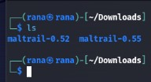

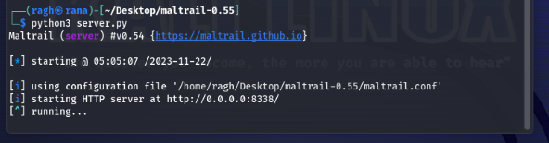

**Or you can set the shell to false.**

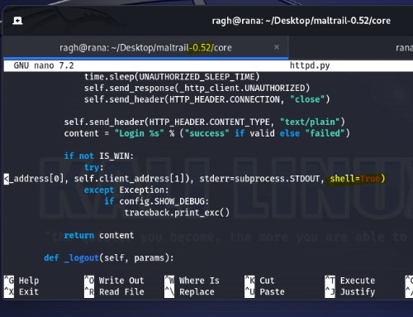

**Screen Tool:**

**Reduce Permissions: Avoid using setuid root if it is unnecessary.**

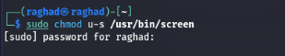

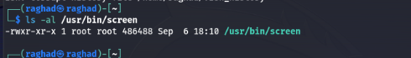

**Update the screen to the latest version that adding permissions check for the logfile name**

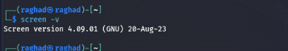

**Replication for each attack with proof showing that it is not working anymore.**

**Ubuntu server**

**In the login page of the wordpress the brute force didn’t give the password**

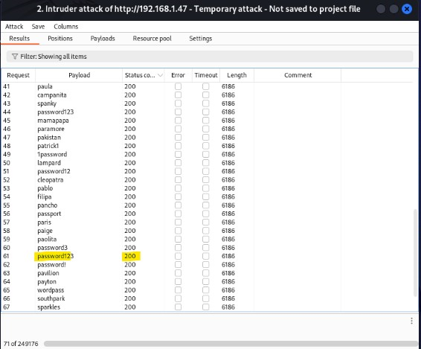

**In hydra it didn’t guesses the password of raghad5, and if there is no vulnerability in the wordpress plugin the user name raghad5 will not be known .**

**And it’s blocked for the too many error.**

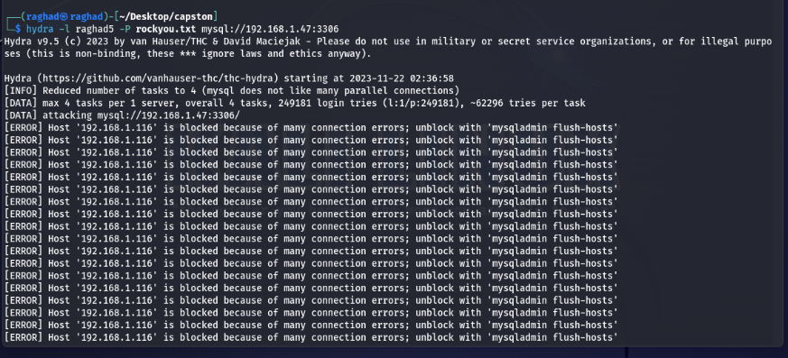

**That’s what will happened if any attacker try to attack the wordpress to make sql injection after updating the plugin**

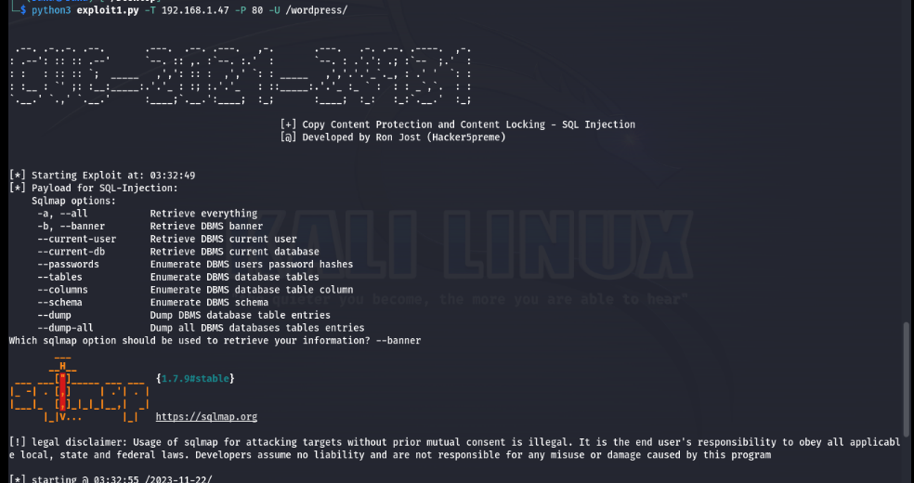

**It will tell that the parameter is not injectable**

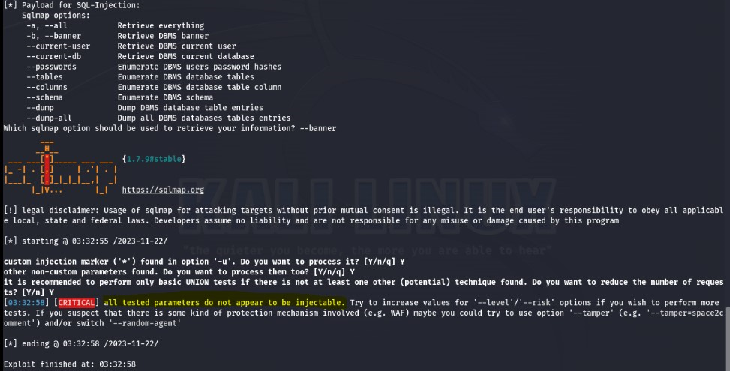

**Use strong hashing like sha512 for the passwords stored in the databases**

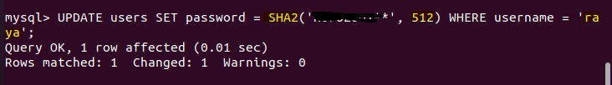

**Rana server**

**The anonymous login become unacceptable in FTP**

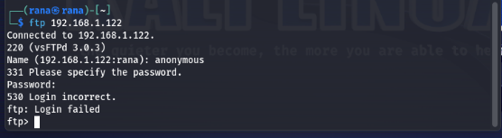

**The login become with authentication**

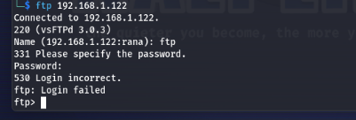

**When running the script to attack the maltrail it didn’t work**

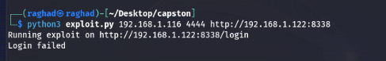

**And when try to make privilege escalation**

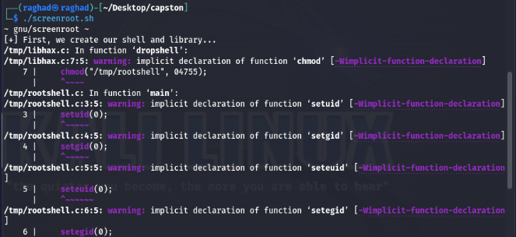

**It will not work after updation the screen version and will become the same user**

